**Cucumber Supplement**



**Cucumber Supplement:**

**Student Workbook**

All written content, source code, and formatting are the property of Trivera Technologies LLC. No portion of this material may be duplicated or reused in any way without the express written consent of Trivera Technologies LLC. For information please contact [Info@triveratech.com](mailto:Info@triveratech.com) or visit [www.triveratech.com.](http://www.triveratech.com/)

All software or hardware products referenced herein are trademarks of their respective holders. Products and company names are the trademarks and registered trademarks of their respective owners. Trivera Technologies has used its best efforts to distinguish proprietary trademarks from descriptive names by following the capitalization style used by the manufacturer.

**Copyright © 2018 Trivera Technologies LLC. All rights reserved.   
Version 20180403**

Lab Exercises

Exercises/Tutorials 4

Exercise 1. Southwest Airlines Flights 5

Exercise 2. Chase Car Buying 22

Exercise 3. HotWire Flights 30

Exercise 4. Chase Home Lending 34

Exercise 5. Walmart Shopping 47

Exercise 6. Facebook Login 51

Exercise 7. JetBlue Vacation 56

Exercise 8. LinkedIn 60

Exercises/Tutorials

**Cucumber Supplement**

Version 20180403

1. Southwest Airlines Flights

|  |  |  |
| --- | --- | --- |
| Overview | |  |
| In this exercise, you will create tests for an active website. | | |
| Objective | Access Southwest.com and look for flight using Cucumber & Selenium tests | |

1. Create a new Java Project.

Go to **File > New > Project > Select Java Project**

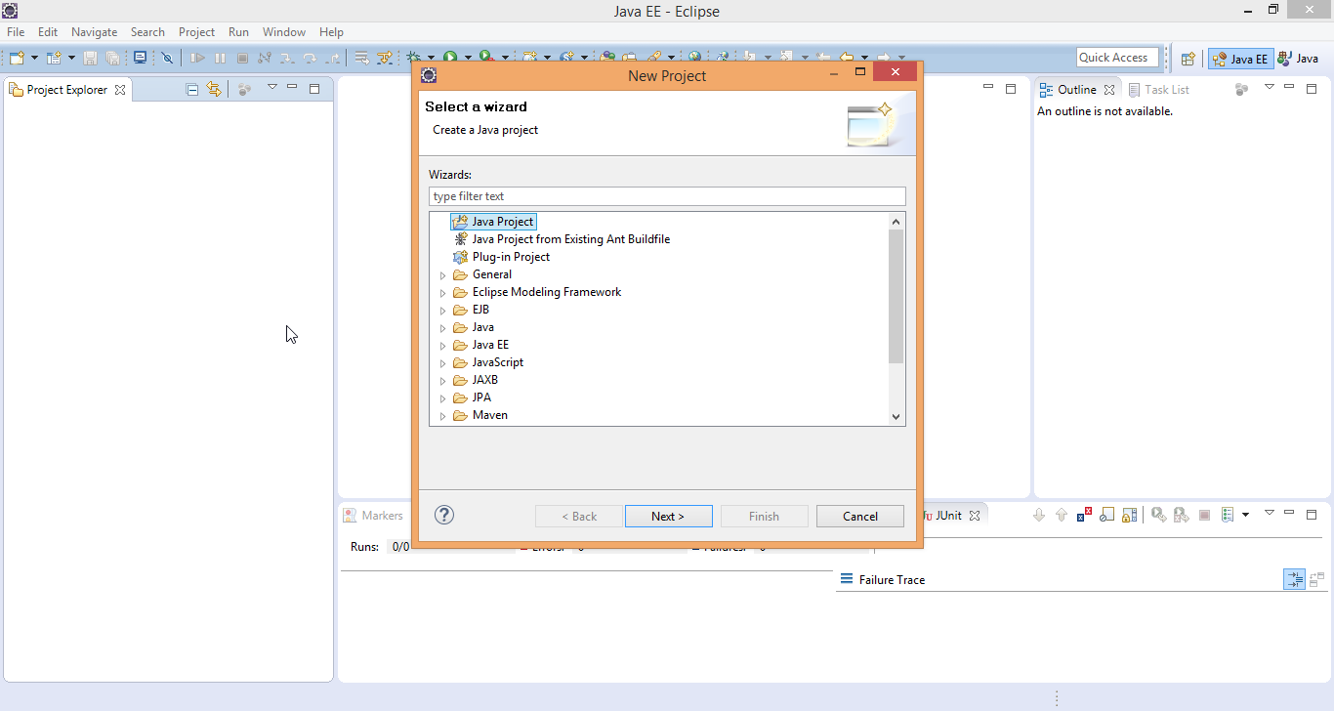

Then press **Next button > Add Project Name**

Project name: **SouthWestWithCucumber**

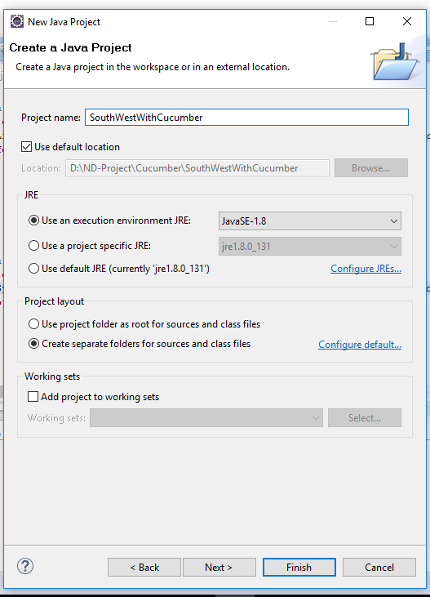

Press the **next** button and then click on the **Finish** button.

1. **Add Selenium & Cucumber jars**

Right click on project > select **Property**

Select **Java Build Path** > select **Libraries** tab > click on **Add External JARs** button

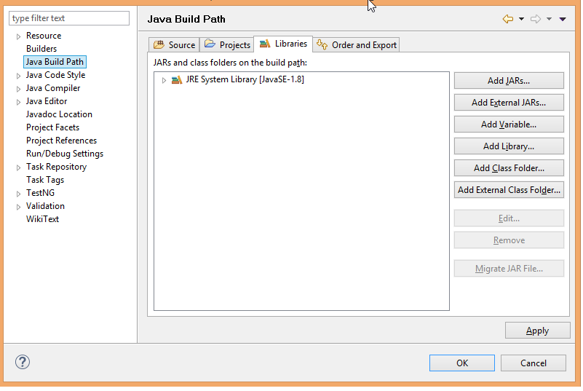

Select the location where Selenium & Cucumber are placed on your computer.

Select all Selenium JAR files.

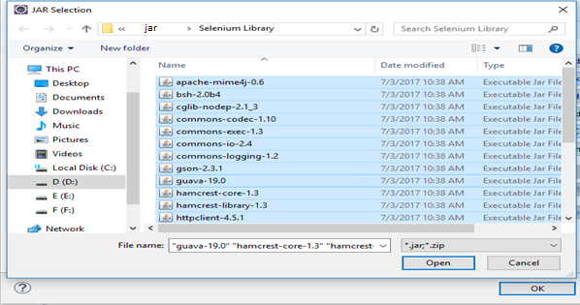

1. Select all the Cucumber JAR files.

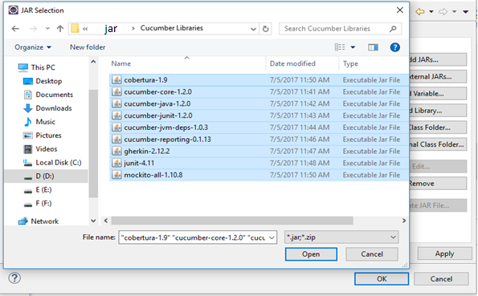

1. Next, add the JUnit 4 Library by clicking on **Add Library -> JUnit -> JUnit4 ->Finish**
2. After adding all the JAR files, click the **OK** button**.**

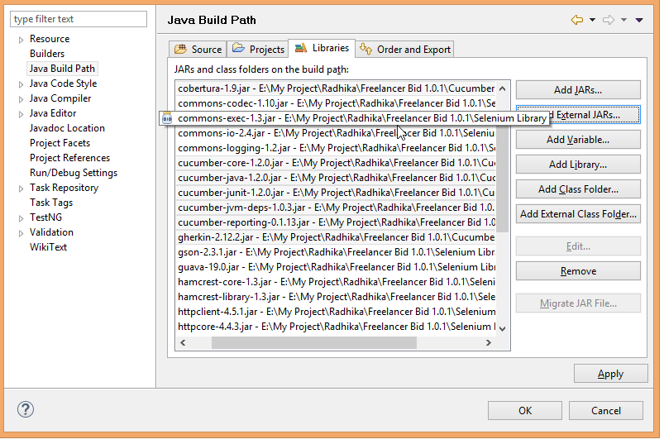

1. We have added all the JAR files. Now we must add a folder inside the project that should be named “Feature”.

Right Click on the project > **New > Folder**

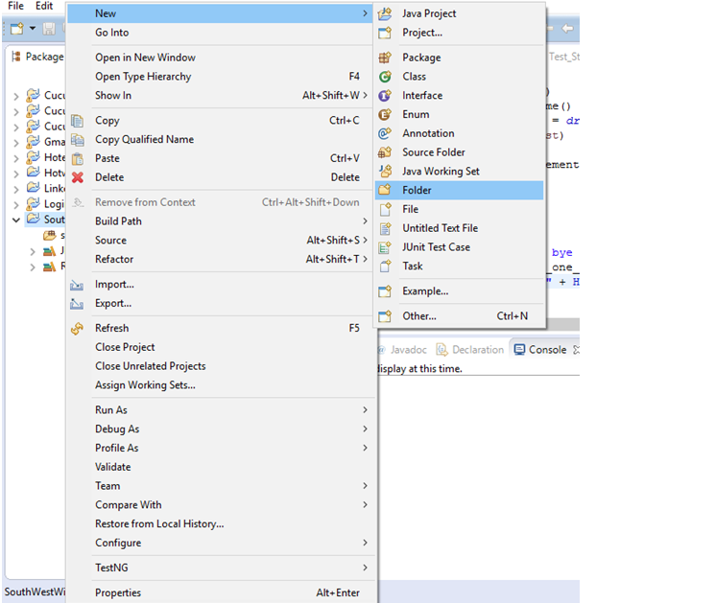

1. Name the folder **“Feature”** then click the **Finish** button.
2. Add a new feature file under the **Feature** folder.

Right click on Feature folder > **New > File**

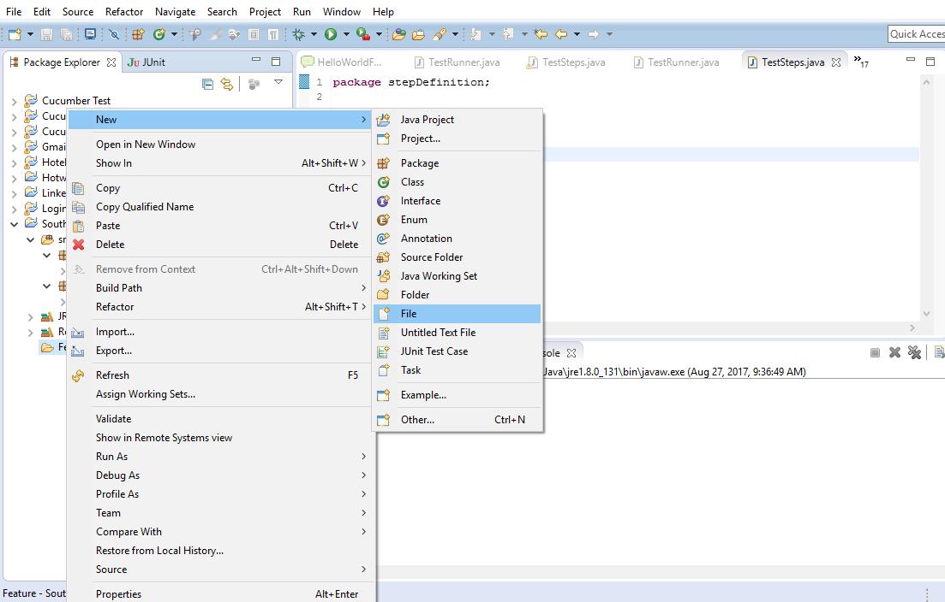

1. Name the file “**SouthWest.feature**” and click the **Finish** button.
2. Write all the scenarios inside **SouthWest.feature** file**.** You can do that, by first removing all the present contents of the feature file.

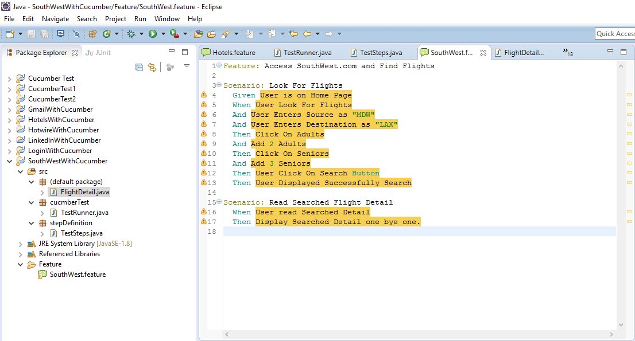

1. Then add the following southwest features below**.**

Feature: Access Southwest.com and Find Flights

Scenario: Look For Flights

Given User is on Home Page

When User Look For Flights

And User Enters Source as "MDW"

And User Enters Destination as "LAX"

Then Click On Adults

And Add 2 Adults

Then Click On Seniors

And Add 3 Seniors

Then User Click On Search Button

Then User Displayed Successfully Search

Scenario: Read Searched Flight Detail

When User read Searched Detail

Then Display Searched Detail one by one.

1. Now, we need to create new package. Right click on the src folder, select new, and then select package.

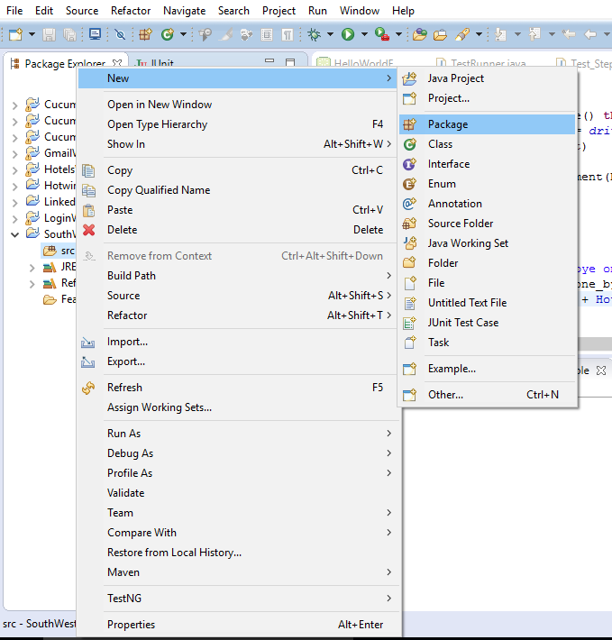

Name the package, “**cucumberTest**”, then click on **Finish** button

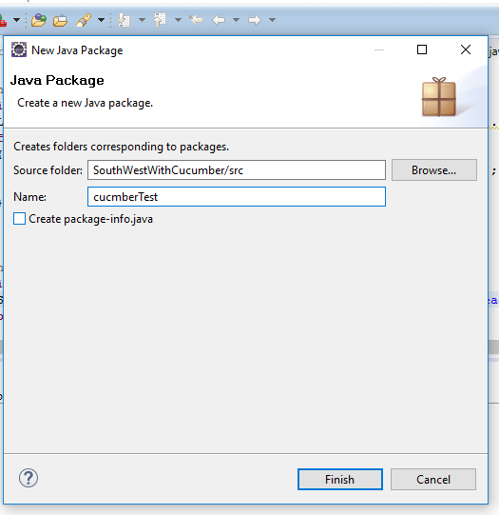

1. Create new class in the “**cucumberTest**” package by right clicking on the “**cucumberTest**” package **> New > Class**

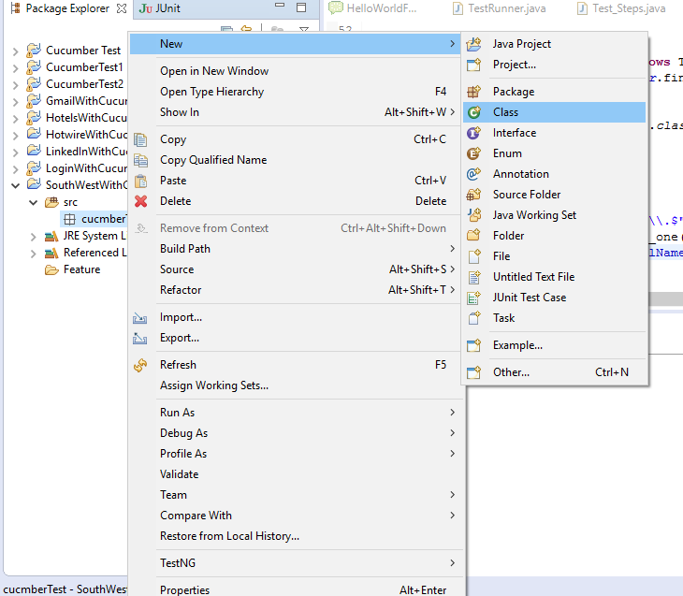

1. Name the class “**TestRunner**”, then click the **Finish** button.

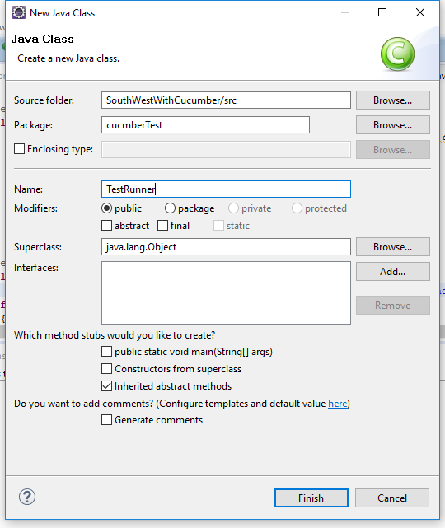

1. Delete all the content of the **TestRunner** class and replace it with the code below:

package cucumberTest;

@RunWith( Cucumber.class )

@CucumberOptions(

features = "Feature"

, glue = {"stepDefinition" }

)

public class TestRunner {

}

1. Create the **stepDefinition** package. This is the package where we will have the automation code.
2. Create a new class “**FlightDetails**” under the **cucumberTest** package.

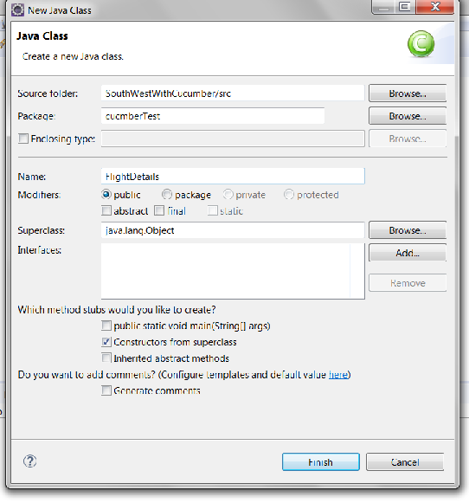

1. Delete the code inside the class.
2. Populate the class with the code shown below (feel free to copy and paste from the solution.

private String departureTime;

public String getDepartTime () {

return this.departureTime;

}

public void setDepartTime (String departureTime) {

this.departureTime = departureTime;

}

private String arrivalTime;

public String getArrivalTime() {

return this.arrivalTime;

}

public void setArrivalTime(String arrivalTime) {

this.arrivalTime = arrivalTime;

}

private String travelTime;

public String getTravelTime () {

return this.travelTime;

}

public void setTravelTime ( String travelTime) {

this.travelTime = travelTime;

}

1. Create a new package under the src folder, and name it “**stepDefinition**”
2. In the **stepDefinition** package, create a new class, name it “**TestSteps**”, then click on the **Finish** button.
3. To produce the skeleton Java code in the **TestSteps** class, we will first setup a **JUnit** class.
4. Create a **TestRunner** class in the **cucumberTest** package.
5. Right click anywhere in the **TestRunner** class and choose **Run As -> JUnit Test**.

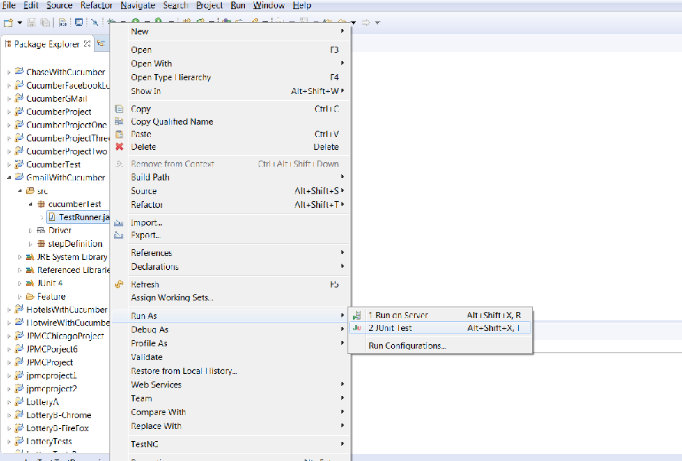

1. This will produce Java code that resembles the default steps in **Gherkin**. It is shown in the console view below.

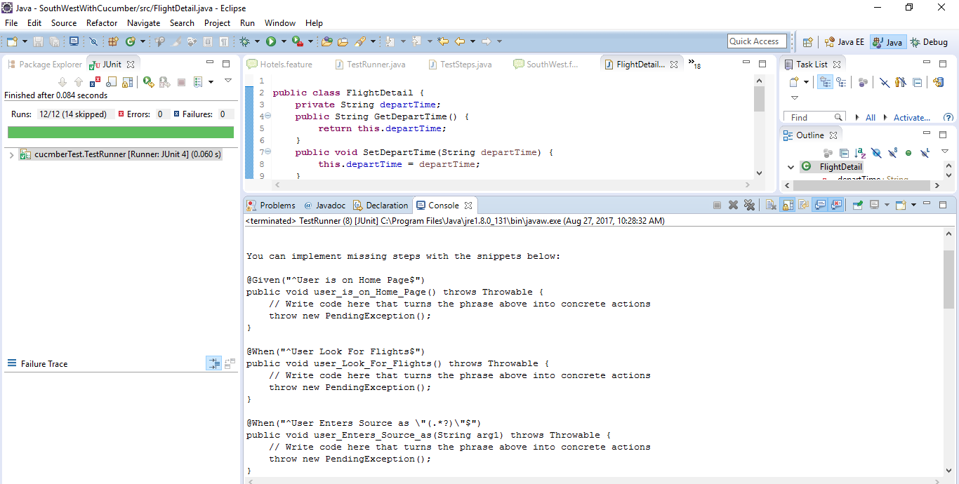

1. Copy all those steps (starting from the line that says **@Given**... until the end of the code) and paste it in the **TestSteps** class.

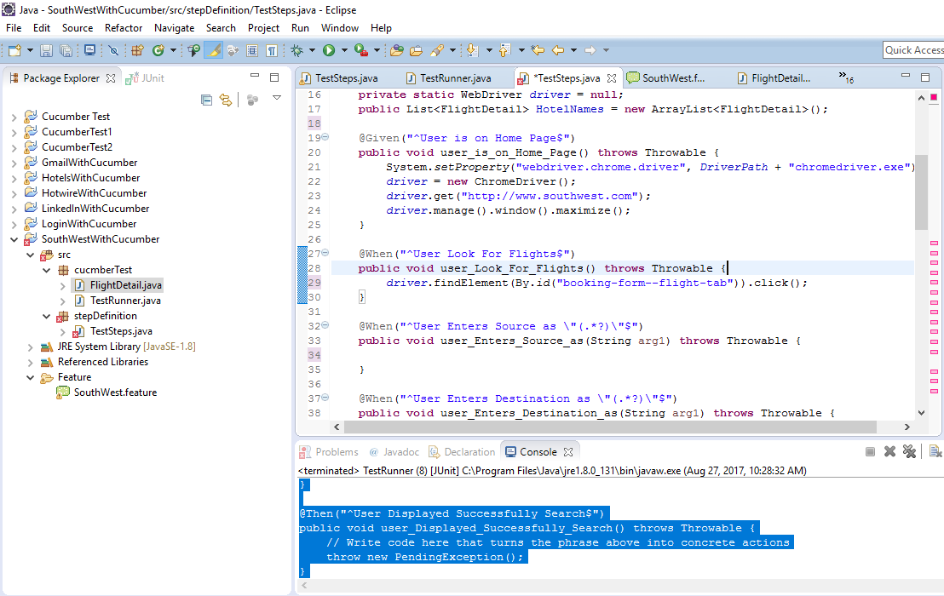

1. Add the code that is bolded below into your **TestSteps** file.

Note: Make sure the code goes in the right location, inside the class.

Note: Make sure you delete the content of each method before pasting the new code. **This is a very important step**.

Note: Make sure you correct your compile errors. For example, holding the three keys Ctrl + Shift + O will allow Eclipse to organize the required import statements.

package stepDefinition;

public class TestSteps {

**public static String driverPath =**

**"C:\\StudentWork\\jars\\ChromeDriver\\";**

**public static WebDriver *driver = null*;**

**public List<FlightDetails> flightDetailsList =**

**new ArrayList<FlightDetails>();**

@Given("^User is on Home Page$")

public void user_is_on_Home_Page() throws Throwable {

**System.*setProperty*("webdriver.chrome.driver",**

***driverPath* + "chromedriver.exe");**

***driver* = new ChromeDriver();**

***driver*.get("http://www.southwest.com");**

***driver*.manage().window().maximize();**

**}**

@When("^User Look For Flights$")

public void user_Look_For_Flights() throws Throwable {

***driver*.findElement(By.*id*("booking-form--flight-tab")).click();**

}

@When("^User Enters Source as \"(.*?)\"$")

public void user_Enters_Source_as(String arg1) throws Throwable {

***driver*.findElement(By.*id*("air-city-departure")).clear();**

***driver*.findElement(By.*id*("air-city-departure")).sendKeys(arg1);**

**Thread.*sleep*(3000);**

***driver*.findElement(By.*cssSelector*("b")).click();**

}

@When("^User Enters Destination as \"(.*?)\"$")

public void user_Enters_Destination_as(String arg1) throws Throwable {

***driver*.findElement(By.*id*("air-city-arrival")).clear();**

***driver*.findElement(By.*id*("air-city-arrival")).sendKeys(arg1);**

**Thread.*sleep*(3000);**

***driver*.findElement(By.*id*("air-city-arrival-menu-item1")).click();**

**Thread.*sleep*(2000);**

}

@Then("^Click On Adults$")

public void click_On_Adults() throws Throwable {

***driver*.findElement(By.*id*("air-pax-count-adults")).click();**

**Thread.*sleep*(2000);**

}

@Then("^Add (\\d+) Adults$")

public void add_Adults(int arg1) throws Throwable {

**for (int i = 0; i <arg1 ; i++) {**

***driver*.findElement(**

**By.*id*("jb-number-selector-more")).click();**

**}**

}

@Then("^Click On Seniors$")

public void click_On_Seniors() throws Throwable {

***driver*.findElement(By.*id*("air-pax-count-seniors")).click();**

**Thread.*sleep*(2000);**

}

@Then("^Add (\\d+) Seniors$")

public void add_Seniors(int arg1) throws Throwable {

**for (int i = 0; i<arg1; i++) {**

***driver*.findElement(**

**By.*id*("jb-number-selector-more")).click();**

**}**

}

@Then("^User Click On Search Button$")

public void user_Click_On_Search_Button() throws Throwable {

***driver*.findElement(By.*id*("jb-booking-form-submit-button")).click();**

}

@Then("^User Displayed Successfully Search$")

public void user_Displayed_Successfully_Search() throws Throwable {

**System.*out*.println("Search successfully Done.");**

}

@When("^User read Searched Detail$")

public void user_read_Searched_Detail() throws Throwable {

**Thread.*sleep*(5000);**

**List<WebElement>trlist =**

***driver*.findElements(By.*className*("bugTableRow"));**

**for (WebElement e : trlist) {**

**FlightDetails f = new FlightDetails();**

**f.setDepartTime(e.findElement(**

**By.*className*("depart_column")).getText());**

**f.setArrivalTime(e.findElement(**

**By.*className*("arrive_column")).getText());**

**f.setTravelTime(e.findElement(**

**By.*cssSelector*("span.bugText.duration")).getText());**

**flightDetailsList.add(f);**

**}**

}

@Then("^Display Searched Detail one bye one\\.$")

public void display_Searched_Detail_one_bye_one() throws Throwable {

**for (FlightDetails f : flightDetailsList ) {**

**System.*out*.println("Depart Time : " + f.getDepartTime() +**

**" Arrival Time : " + f.getArrivalTime()**

**+ " Travel Time : " + f.getTravelTime());**

**}**

}

}

1. Go to **cucumberTest** package > select **TestRunner.java** > right click > **Run As JUnit Test**
2. The test will open a browser and perform all cases.

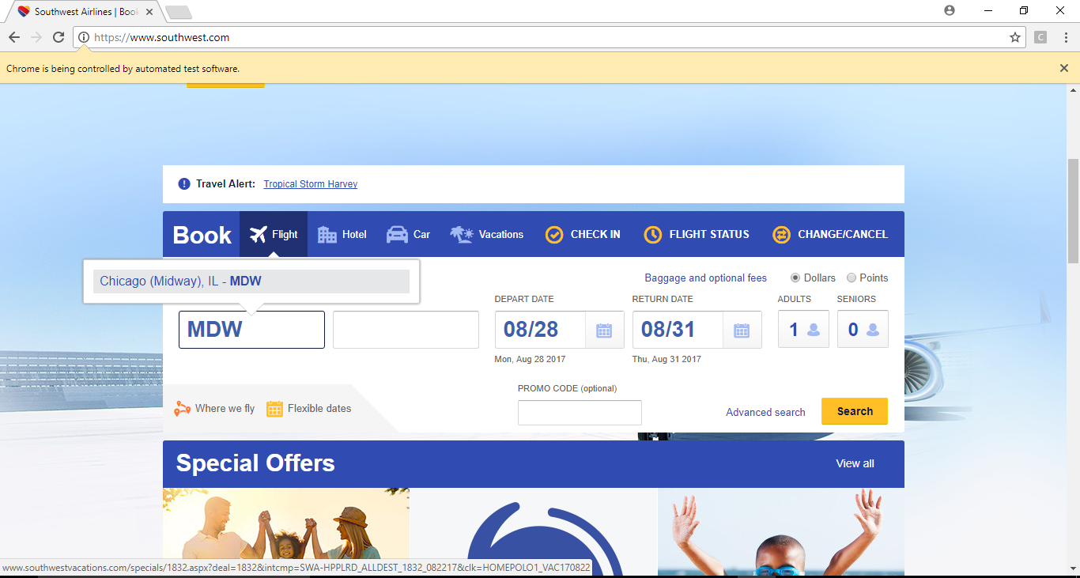

1. While each test case is running, you can see the display of how many cases are passed and failed.
2. Furthermore, you should see the list of flights in the console view, as shown below:

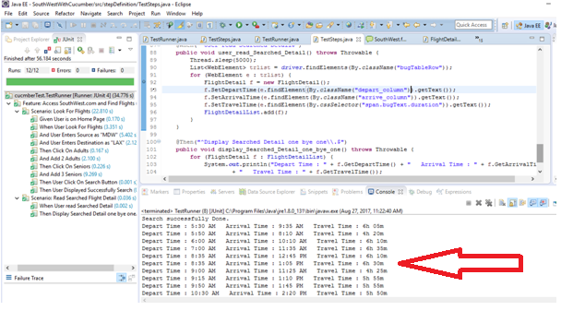

1. Congratulations, you have tested Southwest Airlines landing page.
2. Chase Car Buying

|  |  |  |
| --- | --- | --- |
| Overview | |  |
| In this exercise, you will create tests for an active website. | | |
| Objective | Access Chase.com and look for an option to buy a car using Selenium and Cucumber Tests. | |

1. Create New Java Project named **ChaseWithCucumber**
2. Add **Selenium** and **Cucumbe**r libraries to the project’s build path
3. Add the **Feature** folder to the project.
4. Add feature file to the **Feature** folder and name it “**ChaseBank.feature**”.
5. Write the scenarios inside **ChaseBank.feature** file. Start by deleting all the existing feature file and write scenarios.

Now add the following:

Feature: Verify some common functionalities of chase.com.

Scenario: Looking some option from the sliders

Given User is on chase.com

When User looking for Right option from chase.com

Then User Click on Slider Left and Right

Scenario: Buy a Car

When User clicks on Buy a car

Then User enters in Buy a Car page

Then User select Find a Car

Then User enters in Find a car page

Scenario: Search new Car

When User is going for Search a new car

Then User select make as "Acura"

Then User is looking for New York location and he's enter "10001 zip code

Then User is going for search according to searching parameters

Then User can see the listing of the cars

Then User can check multiple models like "Coupe”, “Hybrid" and "Sedan"

Then User is selected "Sedan" model

Scenario: Build and Price

When User is selected "ILX" car

Then User is click on Build and price button

Then User is going for "View pricing on Local inventory"

Scenario: Customer Pricing

When User wants to verify their information

Then User's First name is "Your F. Name" and Last name is "Your L. Name"

Then User's Home Address is "New York"

Then User's emailid is "Your Email"

Then User's Phone no is "+1 212-662-4548"

Then User clicking on "View pricing on Local Inventory"

Then User accepting term and condition

Then User clicking on "View pricing on Local inventory"

1. Create the “**cucumberTest**” package.
2. Create the “**TestRunner**” class in the “**cucumberTest**” package. Insert this code below into the class.

package cucumberTest;

import org.junit.runner.RunWith;

import cucumber.api.CucumberOptions;

import cucumber.api.junit.Cucumber;

@RunWith(Cucumber.class)

@CucumberOptions(

features = "Feature"

,glue={"stepDefinition"}

)

public class TestRunner {

}

1. Create the new package “**stepDefinition**” and the new class “**TestSteps**” in the new package
2. Now right click on **TestRunner** class and click **Run As** > **JUnit Test**.
3. Copy all those steps and paste in **TestSteps.java** file and add code in those methods.
4. Add the bolded code to your **TestSteps** file.

package stepDefinition;

import java.util.concurrent.TimeUnit;

import org.openqa.selenium.By;

import org.openqa.selenium.Keys;

import org.openqa.selenium.WebDriver;

import org.openqa.selenium.WebElement;

import org.openqa.selenium.chrome.ChromeDriver;

import cucumber.api.java.en.Given;

import cucumber.api.java.en.Then;

import cucumber.api.java.en.When;

public class TestSteps {

**public static String driverPath =**

**"C:\\StudentWork\\jars\\ChromeDriver\\";**

**public static WebDriver driver;**

@Given("^User is on chase\\.com$")

public void user_is_on_chase_com() throws Throwable {

**System.setProperty("webdriver.chrome.driver",**

**DriverPath + "chromedriver.exe");**

**driver = new ChromeDriver();**

**driver.manage().timeouts().implicitlyWait(10, TimeUnit.SECONDS);**

**driver.get("https://www.chase.com/");**

**driver.manage().window().maximize();**

}

@When("^User looking for Right option from chase\\.com$")

public void user_looking_for_Right_option_from_chase_com() throws Throwable {

**driver.findElement(By.xpath("(//button[@type='button'])[3]")).click();**

**driver.manage().timeouts().implicitlyWait(10, TimeUnit.SECONDS);**

}

@Then("^User Click on Slider Left and Right$")

public void user_Click_on_Slider_Left_and_Right() throws Throwable {

// Write code here that turns the phrase above into concrete actions

**driver.findElement(By.xpath("(//button[@type='button'])[3]")).click();**

**driver.manage().timeouts().implicitlyWait(10, TimeUnit.SECONDS);**

**driver.findElement(By.id("firstFocusableElement")).click();**

**driver.manage().timeouts().implicitlyWait(10, TimeUnit.SECONDS);**

}

@When("^User looking for Right option from chase\\.com$")

public void user_looking_for_Right_option_from_chase_com() throws Throwable {

**driver.findElement(By.xpath("(//button[@type='button'])[3]")).click();**

**driver.manage().timeouts().implicitlyWait(10, TimeUnit.SECONDS);**

}

@Then("^User Click on Slider Left and Right$")

public void user_Click_on_Slider_Left_and_Right() throws Throwable {

// Write code here that turns the phrase above into concrete actions

**driver.findElement(By.xpath("(//button[@type='button'])[3]")).click();**

**driver.manage().timeouts().implicitlyWait(10, TimeUnit.SECONDS);**

**driver.findElement(By.id("firstFocusableElement")).click();**

**driver.manage().timeouts().implicitlyWait(10, TimeUnit.SECONDS);**

}

@When("^User is going for Search a new car$")

public void user_is_going_for_Search_a_new_car() throws Throwable {

// Write code here that turns the phrase above into concrete actions

**System.out.println("User selected New Cars.");**

}

@Then("^User select make as \"(.*?)\"$")

public void user_select_make_as(String arg1) throws Throwable {

// Write code here that turns the phrase above into concrete actions

**driver.manage().timeouts().implicitlyWait(10, TimeUnit.SECONDS);**

**WebElement element =**

**driver.findElement(By.id("select2-new-car-make-selector-container"));**

**element.click();**

**WebElement element1 =**

**driver.findElement(By.cssSelector("input.select2-search__field"));**

**element1.clear();**

**element1.sendKeys("Acura");**

**element1.sendKeys(Keys.RETURN);**

}

@Then("^User is looking for newyork location and he's enter \"(\\d+) zip code$")

public void user_is_looking_for_newyork_location_and_he_s_enter_zip_code(int arg1)

throws Throwable {

// Write code here that turns the phrase above into concrete actions

**driver.findElement(By.id("new-car-zip-code-picker")).clear();**

**driver.findElement(By.id("new-car-zip-code-picker")).sendKeys("10001");**

**driver.manage().timeouts().implicitlyWait(10, TimeUnit.SECONDS);**

**}**

@Then("^User is going for search according to searching parameters$")

public void user_is_going_for_search_according_to_searching_parameters() throws Throwable {

// Write code here that turns the phrase above into concrete actions

**driver.findElement(By.cssSelector("button.pCta")).click();**

**driver.manage().timeouts().implicitlyWait(50, TimeUnit.SECONDS);**

}

@Then("^User can see the listing of the cars$")

public void user_can_see_the_listing_of_the_cars() throws Throwable {

// Write code here that turns the phrase above into concrete actions

**driver.navigate().refresh();**

}

@Then("^User can check multiple models like \"(.*?)\",\"(.*?)\" and \"(.*?)\"$")

public void user_can_check_multiple_models_like_and(String arg1, String arg2, String arg3)

throws Throwable {

// Write code here that turns the phrase above into concrete actions

**driver.findElement(By.linkText("Coupe")).click();**

**driver.manage().timeouts().implicitlyWait(10, TimeUnit.SECONDS);**

**driver.findElement(By.linkText("Hybrid")).click();**

**driver.manage().timeouts().implicitlyWait(10, TimeUnit.SECONDS);**

**driver.findElement(By.linkText("Sedan")).click();**

**driver.manage().timeouts().implicitlyWait(10, TimeUnit.SECONDS);**

}

@Then("^User is selected \"(.*?)\" model$")

public void user_is_selected_model(String arg1) throws Throwable {

// Write code here that turns the phrase above into concrete actions

**driver.findElement(By.linkText("Sedan")).click();**

**driver.manage().timeouts().implicitlyWait(10, TimeUnit.SECONDS);**

}

@When("^User is selected \"(.*?)\" car$")

public void user_is_selected_car(String arg1) throws Throwable {

// Write code here that turns the phrase above into concrete actions

**System.out.println("User selected ILX car");**

}

@Then("^User is click on Build and price button$")

public void user_is_click_on_Build_and_price_button() throws Throwable {

// Write code here that turns the phrase above into concrete actions

**driver.findElement(By.cssSelector("button.clearCta")).click();**

**driver.manage().timeouts().implicitlyWait(10, TimeUnit.SECONDS);**

}

@Then("^User is going for \"(.*?)\"$")

public void user_is_going_for(String arg1) throws Throwable {

// Write code here that turns the phrase above into concrete actions

**driver.findElement(By.id("closeModal")).click();**

**Thread.sleep(5000);**

**driver.findElement(By.xpath("//a[contains(text(),**

**'View Pricing on Local Inventory')]")).click();**

**driver.manage().timeouts().implicitlyWait(50, TimeUnit.SECONDS);**

}

@When("^User wants to verify their information$")

public void user_wants_to_verify_their_information() throws Throwable{

// Write code here that turns the phrase above into concrete actions

**System.out.println("In this page user verify their information.");**

}

@Then("^User's First name is \"(.*?)\" and Last name is \"(.*?)\"$")

public void user_s_First_name_is_and_Last_name_is(String arg1, String arg2)

throws Throwable {

**driver.findElement(By.name("givenName")).sendKeys("Ali");**

**driver.findElement(By.name("familyName")).sendKeys("Hamad");**

**driver.manage().timeouts().implicitlyWait(10, TimeUnit.SECONDS);**

}

@Then("^User's Home Address is \"(.*?)\"$")

public void user_s_Home_Address_is(String arg1) throws Throwable {

// Write code here that turns the phrase above into concrete actions

**driver.findElement(By.name("addressLine")).clear();**

**driver.findElement(By.name("addressLine")).sendKeys("New York");**

**driver.manage().timeouts().implicitlyWait(10, TimeUnit.SECONDS);**

}

@Then("^User's emailid is \"(.*?)\"$")

public void user_s_emailid_is(String arg1) throws Throwable {

// Write code here that turns the phrase above into concrete actions

**driver.findElement(By.name("emailAddress")).clear();**

**driver.findElement(**

**By.name("emailAddress")).sendKeys("youremail@yahoo.com");**

**driver.manage().timeouts().implicitlyWait(10, TimeUnit.SECONDS);**

}

@Then("^User's Phone no is \"(.*?)\"$")

public void user_s_Phone_no_is(String arg1) throws Throwable {

**driver.findElement(By.name("telephone")).clear();**

**driver.findElement(By.name("telephone")).sendKeys("+1 212-662-4548");**

**driver.manage().timeouts().implicitlyWait(10, TimeUnit.SECONDS);**

}

@Then("^User clicking on \"(.*?)\"$")

public void user_clicking_on(String arg1) throws Throwable {

// Write code here that turns the phrase above into concrete actions

**driver.manage().timeouts().implicitlyWait(50, TimeUnit.SECONDS);**

**driver.findElement(**

**By.cssSelector("div.col-sm-12 > input.pCta")).click();**

**driver.manage().timeouts().implicitlyWait(50, TimeUnit.SECONDS);**

}

@Then("^User accepting term and condition$")

public void user_accepting_term_and_condition() throws Throwable {

// Write code here that turns the phrase above into concrete actions

**Thread.sleep(5000);**

**driver.findElement(By.cssSelector("#tosWidget > label")).click();**

**driver.manage().timeouts().implicitlyWait(50, TimeUnit.SECONDS);**

**driver.findElement(**

**By.cssSelector("#dealerFormContent > input.pCta")).click();**

}

}

1. Select **TestRunner.java** > right click > **Run As > JUnit Test**
2. It will open a browser and perform all cases.

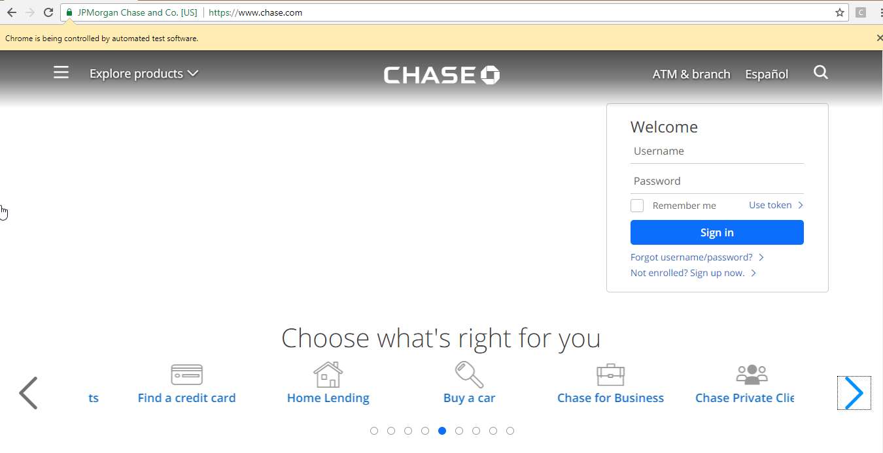

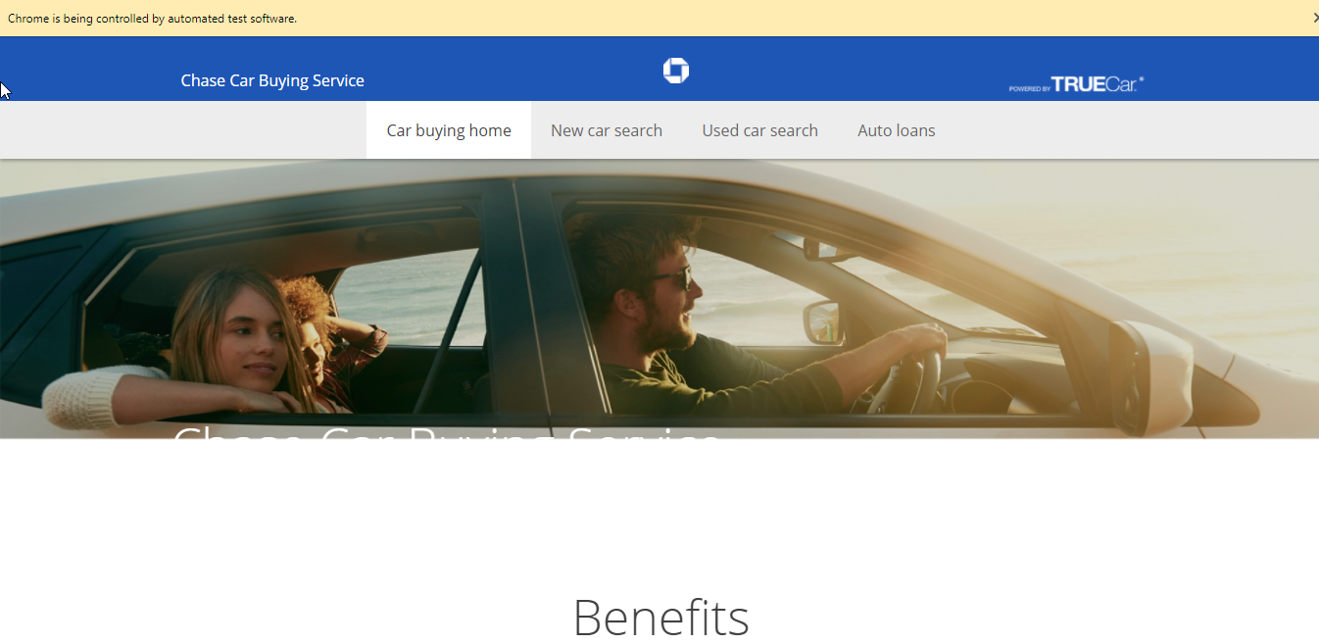

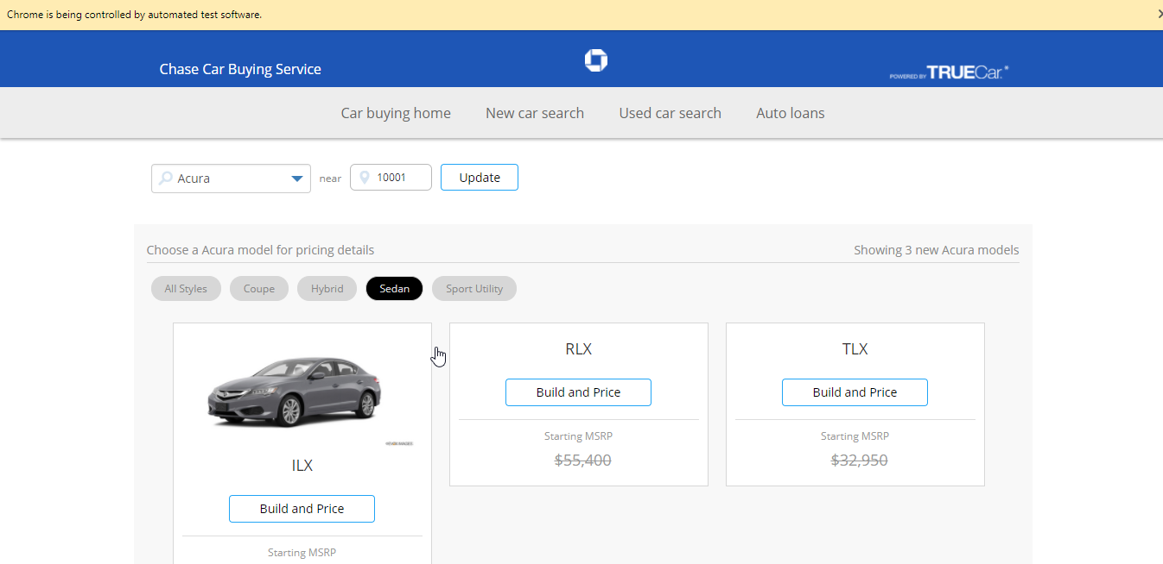

1. When each test case is running, it displays how many cases are passed and failed.

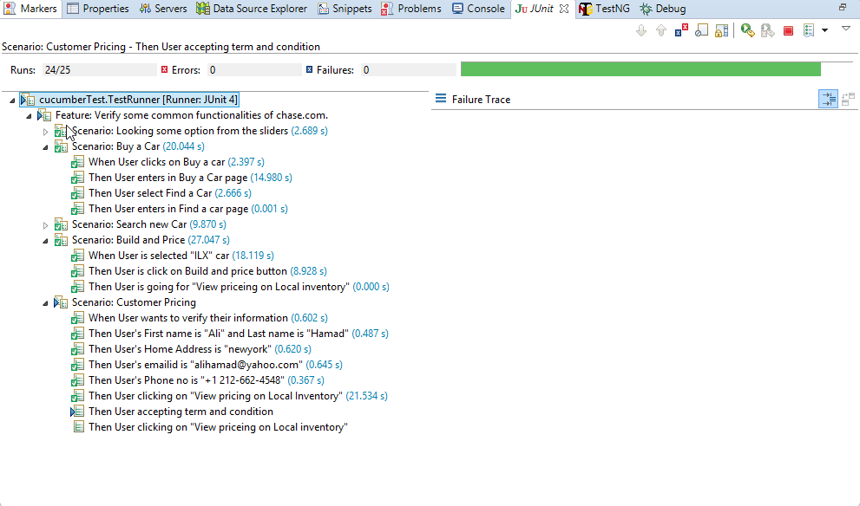

1. HotWire Flights

|  |  |  |
| --- | --- | --- |
| Overview | |  |
| In this exercise, you will create tests for an active website. | | |
| Objective | Access HotWire.com and look for flights using Selenium and Cucumber tests | |

1. Create new Java project named **HotwireWithCucumber**
2. Add **Selenium** and **Cucumbe**r libraries to the project’s build path
3. Add the **Feature** folder to the project.
4. Add feature file to the **Feature** folder and name it “**HotwireLogin.feature**”
5. Write all the scenarios inside **HotwireLogin.feature** file. Start by deleting all the existing feature file and write scenarios.

Now add the following:

**Feature: Access HotWire and Look for Flights**

**Scenario: Look for Flights**

**Given User is on Home Page**

**When User Look For Flights**

**And User Enters Source as "JFK"**

**And User Enters Destination as "ORD"**

**Then User Click On Find Flight Button**

**Then User Displayed Successfully Search**

1. Create the “**cucumberTest**” package.
2. Create the “**TestRunner**” class in the “**cucumberTest**” package. Insert this code below into the class.

package cucumberTest;

import org.junit.runner.RunWith;

import cucumber.api.CucumberOptions;

import cucumber.api.junit.Cucumber;

@RunWith(Cucumber.class)

@CucumberOptions(

features = "Feature"

,glue={"stepDefinition"}

)

public class TestRunner {

}

1. Create the new package “**stepDefinition**” and the new class “**TestSteps**” in the new package
2. Now right click on **TestRunner** class and click **Run As** > **JUnit Test**.
3. Copy all those steps and paste in **TestSteps.java** file and add code in those methods.
4. Add the bolded code to your **TestSteps** file.

package stepDefinition;

import org.openqa.selenium.By;

import org.openqa.selenium.WebDriver;

import org.openqa.selenium.chrome.ChromeDriver;

import cucumber.api.java.en.Given;

import cucumber.api.java.en.Then;

import cucumber.api.java.en.When;

public class TestSteps {

**public static String DriverPath =**

**"C:\\StudentWork\\jars\\ChromeDriver\\";**

**private static WebDriver *driver* = null;**

@Given("^User is on Home Page$")

public void user_is_on_Home_Page() throws Throwable {

**System.setProperty("webdriver.chrome.driver",**

**DriverPath + "chromedriver.exe");**

**driver = new ChromeDriver();**

**driver.get("http://www.hotwire.com");**

**driver.manage().window().maximize();**

}

@When("^User Look For Flights$")

public void user_Look_For_Flights() throws Throwable {

***driver*.findElement(**

**By.*xpath*("//div[@id='options-errors-container']/uhp-vertical-options/div/div/div[3]/div[3]/label"))**

**.click();**

}

@When("^User Enters Source as \"(.*?)\"$")

public void user_Enters_Source_as(String arg1) throws Throwable {

***driver*.findElement(By.*id*("originAirport")).clear();**

***driver*.findElement(By.*id*("originAirport")).sendKeys(arg1);**

**Thread.*sleep*(3000);**

***driver*.findElement(By.*cssSelector*("strong")).click();**

}

@When("^User Enters Destination as \"(.*?)\"$")

public void user_Enters_Destination_as(String arg1) throws Throwable {

***driver*.findElement(By.*id*("destinationAirport")).clear();**

***driver*.findElement(By.*id*("destinationAirport")).sendKeys(arg1);**

**Thread.*sleep*(3000);**

***driver*.findElement(By.*cssSelector*("strong")).click();**

}

@Then("^User Click On Find Flight Button$")

public void user_Click_On_Find_Flight_Button() throws Throwable {

***driver*.findElement(By.*xpath*("//button[@id='']")).click();**

}

@Then("^User Displayed Successfully Search$")

public void user_Displayed_Successfully_Search() throws Throwable {

**Thread.*sleep*(3000);**

**System.*out*.println("Successfully Flight searched.");**

}

}

1. Select **TestRunner.java** > right click > **Run As > JUnit Test**
2. It will open a browser and perform all cases.

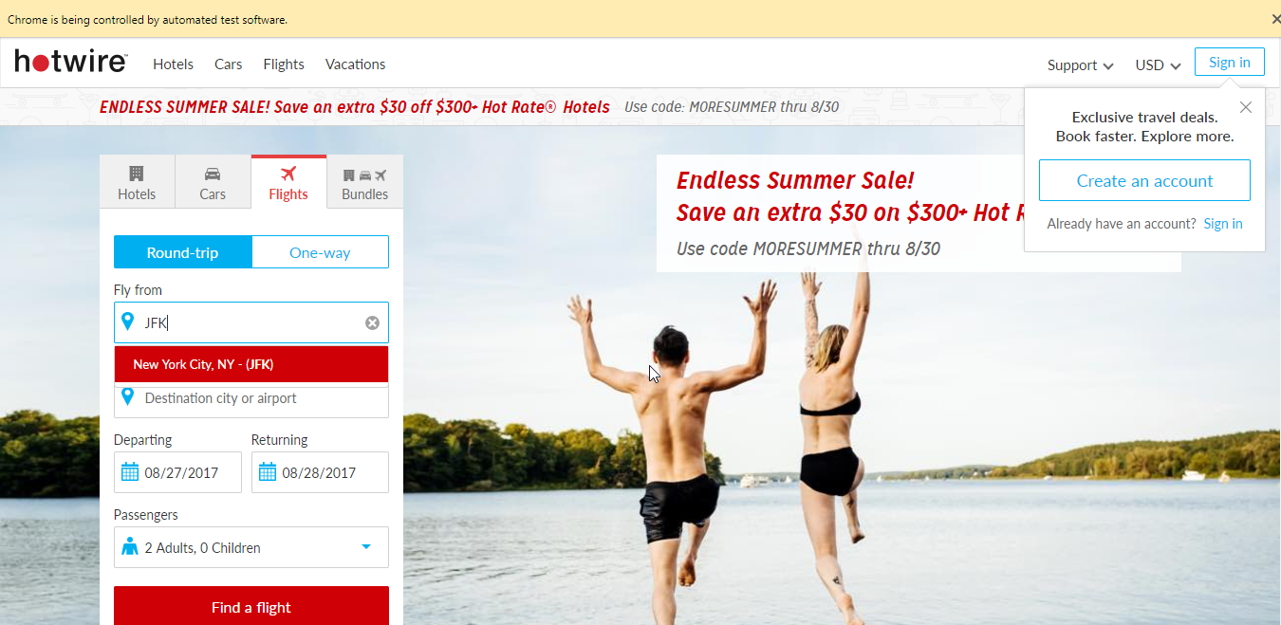

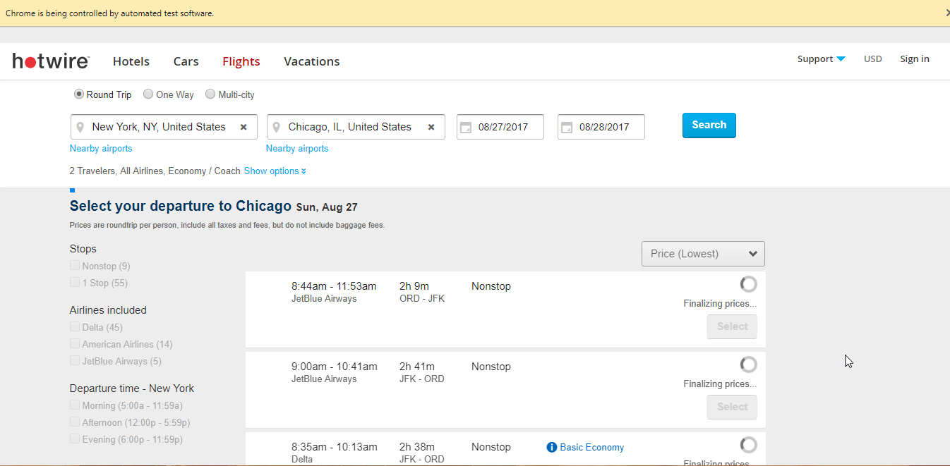

1. When each test case is running, it displays how many cases are passed and failed.

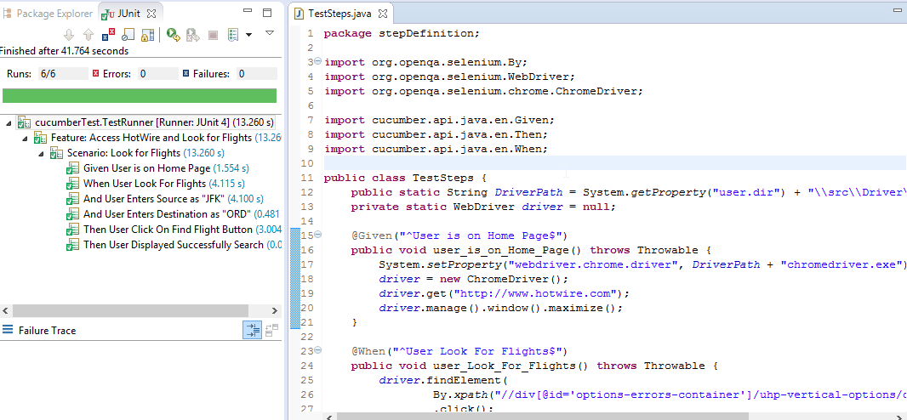

1. Chase Home Lending

|  |  |  |
| --- | --- | --- |
| Overview | |  |
| In this exercise, you will create tests for an active website. | | |
| Objective | Access Chase.com and look for home lending, using Cucumber and Selenium Tests. | |

1. Create New Java Project named **ChaseWithCucumber**
2. Add **Selenium** and **Cucumbe**r libraries to the project’s build path
3. Add the **Feature** folder to the project.
4. Add feature file to the **Feature** folder and name it “**Chase-HomeLanding.feature**”
5. Write the scenarios inside **Chase-HomeLanding.feature** file. Start by deleting all the existing feature file and write scenarios.

Note: It is very important to use your own user name, password, your email address, and your own address information

1. Now add the following:

Feature: Access Chase.com and Look for Home Landing

Scenario: Look for Home Landing

Given User is on Home Page.

Then User Select Home Landing

Then User Select Buy a Home

Then User Displayed Form

Scenario: User Fill up Getting Started Up Tab

When Select Loan Purpose as No

And User Select Loan Type as "30-yr Fixed"

And User Select How did you find this from? as "Referral"

And User Select Did you have Chase account as No

Then User Click On Continue

Scenario: Use Fill up Applicant’s Personal Information Tab

When User enters "Test" as First Name

And User enters "T" as MI

And User enters "Test" as Last Name

And User enters "01/01/1990" as Date Of Birth

And User enters "1234567890" as Primary Phone Number

And User Select "Mobile Phone" as Phone Type

And User enters "your email" as Email

And User Select "U.S. Citizen" as Residence Status

And User enters "AAAAAAAA" as Current address lineOne

And User enters "BBBBBB" as Current address lineTwo

And User enters "CCCCCC" as City

And User Select "Alabama" as State

And User enters "35010" as Zip

And User Select "Rent" as Residential Status

And User Select Have you lived here for more than two years? as Yes

And User Select Is your mailing address the same as your current residence? as Yes

And User Select Are you a first-time homebuyer? as Yes

And User Select Do you have a coapplicant? as No

Then User Click On Continue

Scenario: User Fill up Property & Loan Information Tab

When User enters "hgeh" as City for Property

And User enters "Alabama" as State for Property

And User enters "35010" as Zip for Property

And User Select "Single Family" as Property Type

And User Select "Primary Residence" as Use of Property

And User enters 12 as Purchase Price

And User enters 12 as Down payment amount

And User enters 14 as Annual real estate taxes

And User enters 10 as Annual hazard insurance premium

And User enters 9 as Annual flood insurance premium

And User Select Do you have a real estate agent? as No

And User Select "Less than 30 days" as when do you plan on buying a home?

And User Select Do you have a purchase agreement/contract? as No

And User Select Do you have a home equity loan, home equity line of credit or any other mortgage loans? as No

Then User Click On Continue

Scenario: User Fill up About Your Finances Tab

When User enters 15 as Total annual income (before taxes)

And User enters 12 as Total assets

Then User Click On Continue

Scenario: User Fill up Verify Tab

When User read all information

Then User Click On Continue

Scenario: User Fill up Submit Tab

When User enters 1234567890 as Social Security Number

Then User Click On Submit

Then User Displayed Thanks for Request.

1. Create the “**cucumberTest**” package.
2. Create the “**TestRunner**” class in the “**cucumberTest**” package. Insert this code below into the class.

package cucumberTest;

@RunWith(Cucumber.class)

@CucumberOptions(

features = "Feature"

,glue={"stepDefinition"}

)

public class TestRunner {

}

public class TestRunner {

}

1. Create the new package “**stepDefinition**” and the new class “**TestSteps**” in the new package
2. Now right click on **TestRunner** class and click **Run As** > **JUnit Test**.
3. Copy all those steps and paste in **TestSteps.java** file and add code in those methods.
4. Add the bolded code to your **TestSteps** file.

package stepDefinition;

import java.util.concurrent.TimeUnit;

import org.openqa.selenium.By;

import org.openqa.selenium.JavascriptExecutor;

import org.openqa.selenium.WebDriver;

import org.openqa.selenium.WebElement;

import org.openqa.selenium.chrome.ChromeDriver;

import org.openqa.selenium.support.ui.Select;

import cucumber.api.PendingException;

import cucumber.api.java.en.Given;

import cucumber.api.java.en.Then;

import cucumber.api.java.en.When;

public class TestSteps {

**public static String *DriverPath* = "C:\\StudentWork\\jars\\ChromeDriver\\";**

**private static WebDriver *driver* = null;**

@Given("^User is on Home Page\\.$")

public void user_is_on_Home_Page() throws Throwable {

**System.setProperty("webdriver.chrome.driver",**

**DriverPath + "chromedriver.exe");**

**driver = new ChromeDriver();**

**driver.get("http://www.chase.com");**

**driver.manage().window().maximize();**

}

@Then("^User Select Home Landing$")

public void user_Select_Home_Landing() throws Throwable {

**driver.manage().timeouts().implicitlyWait(10, TimeUnit.SECONDS);**

**driver.findElement(**

**By.xpath("//div[@id='slick-slide03']/a/div")).click();**

}

@Then("^User Select Buy a Home$")

public void user_Select_Buy_a_Home() throws Throwable {

**driver.manage().timeouts().implicitlyWait(30, TimeUnit.SECONDS);**

**driver.findElement(**

**By.xpath("//*[contains(text(), 'Start online')]")).click();**

}

@Then("^User Displayed Form$")

**public** **void** user_Displayed_Form() **throws** Throwable {

**driver.manage().timeouts().implicitlyWait(10, TimeUnit.SECONDS);**

**System.out.println("User is on mortgage page and will fill up form");**

}

@When("^Select Loan Purpose as No$")

**public** **void** select_Loan_Purpose_as_No() **throws** Throwable {

**driver.manage().timeouts().implicitlyWait(10, TimeUnit.SECONDS);**

**driver.findElement(**

**By.id("ctl00_CenterContentPlaceHolder_LoanPurchase")).click();**

}

@When("^User Select Loan Type as \"(.*?)\"$")

public void user_Select_Loan_Type_as(String arg1) throws Throwable {

**driver.manage().timeouts().implicitlyWait(10, TimeUnit.SECONDS);**

**new Select(driver.findElement(By.id(**

**"ctl00_CenterContentPlaceHolder_LoanTypeList")))**

**.selectByVisibleText(arg1);**

}

@When("^User Select How did you find this from\\? as \"(.*?)\"$")

public void user_Select_How_did_you_find_this_from_as(String arg1) throws Throwable {

**driver.manage().timeouts().implicitlyWait(10, TimeUnit.SECONDS);**

**new Select(driver.findElement(**

**By.id("ctl00_CenterContentPlaceHolder_FindList")))**

**.selectByVisibleText(arg1);**

}

@When("^User Select Did you have Chase account as No$")

public void user_Select_Did_you_have_Chase_account_as_No() throws Throwable {

**driver.manage().timeouts().implicitlyWait(10, TimeUnit.SECONDS);**

**driver.findElement(**

**By.id("ctl00_CenterContentPlaceHolder_IsChaseAccountNo")).click();**

}

@Then("^User Click On Continue$")

public void user_Click_On_Continue() throws Throwable {

**driver.manage().timeouts().implicitlyWait(10, TimeUnit.SECONDS);**

**WebElement element = driver.findElement(**

**By.id("ctl00_WorkflowContentPlaceHolder_NextButton"));**

**JavascriptExecutor executor = (JavascriptExecutor)driver;**

**executor.executeScript("arguments[0].click()", element);**

}

@When("^User enters \"(.*?)\" as First Name$")

public void user_enters_as_First_Name(String arg1) throws Throwable {

**driver.manage().timeouts().implicitlyWait(10, TimeUnit.SECONDS);**

**driver.findElement(**

**By.id("ctl00_CenterContentPlaceHolder_txtFirstName")).clear();**

**driver.findElement(**

**By.id("ctl00_CenterContentPlaceHolder_txtFirstName")).sendKeys(arg1);**

}

@When("^User enters \"(.*?)\" as MI$")

public void user_enters_as_MI(String arg1) throws Throwable {

**driver.manage().timeouts().implicitlyWait(10, TimeUnit.SECONDS);**

**driver.findElement(**

**By.id("ctl00_CenterContentPlaceHolder_txtMiddleInitial")).clear();**

**driver.findElement(**

**By.id("ctl00_CenterContentPlaceHolder_txtMiddleInitial"))**

**.sendKeys(arg1);**

}

@When("^User enters \"(.*?)\" as Last Name$")

public void user_enters_as_Last_Name(String arg1) throws Throwable {

**driver.manage().timeouts().implicitlyWait(10, TimeUnit.SECONDS);**

**driver.findElement(**

**By.id("ctl00_CenterContentPlaceHolder_txtLastName")).clear();**

**driver.findElement(**

**By.id("ctl00_CenterContentPlaceHolder_txtLastName")).sendKeys(arg1);**

}

@When("^User enters \"(.*?)\" as Date Of Birth$")

public void user_enters_as_Date_Of_Birth(String arg1) throws Throwable {

**driver.manage().timeouts().implicitlyWait(10, TimeUnit.SECONDS);**

**driver.findElement(**

**By.id("ctl00_CenterContentPlaceHolder_DateOfBirth")).clear();**

**driver.findElement(**

**By.id("ctl00_CenterContentPlaceHolder_DateOfBirth")).sendKeys(arg1);**

}

@When("^User enters \"(.*?)\" as Primary Phone Number$")

public void user_enters_as_Primary_Phone_Number(String arg1) throws Throwable {

**driver.manage().timeouts().implicitlyWait(10, TimeUnit.SECONDS);**

**driver.findElement(**

**By.id("ctl00_CenterContentPlaceHolder_PrimaryPhoneNumberArea"))**

**.clear();**

**driver.findElement(**

**By.id("ctl00_CenterContentPlaceHolder_PrimaryPhoneNumberArea"))**

**.sendKeys("545");**

**driver.findElement(**

**By.id("ctl00_CenterContentPlaceHolder_PrimaryPhoneNumberPrefix"))**

**.clear();**

**driver.findElement(**

**By.id("ctl00_CenterContentPlaceHolder_PrimaryPhoneNumberPrefix"))**

**.sendKeys("456");**

**driver.findElement(**

**By.id("ctl00_CenterContentPlaceHolder_PrimaryPhoneNumberLine"))**

**.clear();**

**driver.findElement(**

**By.id("ctl00_CenterContentPlaceHolder_PrimaryPhoneNumberLine"))**

**.sendKeys("5455");**

}

@When("^User Select \"(.*?)\" as Phone Type$")

public void user_Select_as_Phone_Type(String arg1) throws Throwable {

**driver.manage().timeouts().implicitlyWait(10, TimeUnit.SECONDS);**

**new Select(driver.findElement(**

**By.id("ctl00_CenterContentPlaceHolder_PrimaryPhoneType")))**

**.selectByVisibleText(arg1);**

}

@When("^User enters \"(.*?)\" as Email$")

public void user_enters_as_Email(String arg1) throws Throwable {

**driver.manage().timeouts().implicitlyWait(10, TimeUnit.SECONDS);**

**driver.findElement(**

**By.id("ctl00_CenterContentPlaceHolder_EmailAddress")).clear();**

**driver.findElement(**

**By.id("ctl00_CenterContentPlaceHolder_EmailAddress")).sendKeys(arg1);**

}

@When("^User Select \"(.*?)\" as Residence Status$")

public void user_Select_as_Residence_Status(String arg1) throws Throwable {

**driver.manage().timeouts().implicitlyWait(10, TimeUnit.SECONDS);**

**new Select(driver.findElement(**

**By.id("ctl00_CenterContentPlaceHolder_residencystatus")))**

**.selectByVisibleText(arg1);**

}

@When("^User enters \"(.*?)\" as Current address lineOne$")

public void user_enters_as_Current_address_lineOne(String arg1) throws Throwable {

**driver.manage().timeouts().implicitlyWait(10, TimeUnit.SECONDS);**

**driver.findElement(**

**By.id("ctl00_CenterContentPlaceHolder_ApplicantCurrentAddress_StreetAddress1TextBox")).clear();**

**driver.findElement(**

**By.id("ctl00_CenterContentPlaceHolder_ApplicantCurrentAddress_StreetAddress1TextBox")).sendKeys(arg1);**

}

@When("^User enters \"(.*?)\" as Current address lineTwo$")

public void user_enters_as_Current_address_lineTwo(String arg1) throws Throwable {

**driver.manage().timeouts().implicitlyWait(10, TimeUnit.SECONDS);**

**driver.findElement(**

**By.id("ctl00_CenterContentPlaceHolder_ApplicantCurrentAddress_StreetAddress2TextBox")).clear();**

**driver.findElement(**

**By.id("ctl00_CenterContentPlaceHolder_ApplicantCurrentAddress_StreetAddress2TextBox")).sendKeys(arg1);**

}

@When("^User enters \"(.*?)\" as City$")

public void user_enters_as_City(String arg1) throws Throwable {

**driver.manage().timeouts().implicitlyWait(10, TimeUnit.SECONDS);**

**driver.findElement(**

**By.id("ctl00_CenterContentPlaceHolder_ApplicantCurrentAddress_CityTextBox")).clear();**

**driver.findElement(**

**By.id("ctl00_CenterContentPlaceHolder_ApplicantCurrentAddress_CityTextBox")).sendKeys(arg1);**

}

@When("^User Select \"(.*?)\" as State$")

public void user_Select_as_State(String arg1) throws Throwable {

**driver.manage().timeouts().implicitlyWait(10, TimeUnit.SECONDS);**

**new Select(driver.findElement(**

**By.id("ctl00_CenterContentPlaceHolder_ApplicantCurrentAddress_AddressStateDropDownList"))).selectByVisibleText(arg1);**

}

@When("^User enters \"(.*?)\" as Zip$")

public void user_enters_as_Zip(String arg1) throws Throwable {

**driver.manage().timeouts().implicitlyWait(10, TimeUnit.SECONDS);**

**driver.findElement(**

**By.id("ctl00_CenterContentPlaceHolder_ApplicantCurrentAddress_ZipCodeTextBox")).clear();**

**driver.findElement(**

**By.id("ctl00_CenterContentPlaceHolder_ApplicantCurrentAddress_ZipCodeTextBox")).sendKeys(arg1);**

}

@When("^User Select \"(.*?)\" as Residential Status$")

public void user_Select_as_Residential_Status(String arg1) throws Throwable {

**driver.manage().timeouts().implicitlyWait(10, TimeUnit.SECONDS);**

**new Select(driver.findElement(**

**By.id("ctl00_CenterContentPlaceHolder_residentialstatus")))**

**.selectByVisibleText(arg1);**

}

@When("^User Select Have you lived here for more than two years\\? as Yes$")

public void user_Select_Have_you_lived_here_for_more_than_two_years_as_Yes()

throws Throwable {

**driver.manage().timeouts().implicitlyWait(10, TimeUnit.SECONDS);**

**driver.findElement(**

**By.id("ctl00_CenterContentPlaceHolder_IsMoreThan2YearsYes")).click();**

}

@When("^User Select Is your mailing address the same as your current residence\\? as Yes$")

public void user_Select_Is_your_mailing_address_the_same_as_your_current_residence_as_Yes()

throws Throwable {

**driver.manage().timeouts().implicitlyWait(10, TimeUnit.SECONDS);**

**driver.findElement(**

**By.id("ctl00_CenterContentPlaceHolder_IsSameAsCurrentYes")).click();**

}

@When("^User Select Are you a first-time homebuyer\\? as Yes$")

public void user_Select_Are_you_a_first_time_homebuyer_as_Yes() throws Throwable {

**driver.manage().timeouts().implicitlyWait(10, TimeUnit.SECONDS);**

**driver.findElement(**

**By.id("ctl00_CenterContentPlaceHolder_IsAppFirstTimeBuyerYes"))**

**.click();**

}

@When("^User Select Do you have a coapplicant\\? as No$")

public void user_Select_Do_you_have_a_coapplicant_as_No() throws Throwable {

**driver.manage().timeouts().implicitlyWait(10, TimeUnit.SECONDS);**

**WebElement element = driver.findElement(**

**By.id("ctl00_CenterContentPlaceHolder_HasCoApplicantAddDetailsNo"));**

**JavascriptExecutor executor = (JavascriptExecutor)driver;**

**executor.executeScript("arguments[0].click()", element);**

}

@When("^User enters \"(.*?)\" as City for Property$")

public void user_enters_as_City_for_Property(String arg1) throws Throwable {

**driver.manage().timeouts().implicitlyWait(10, TimeUnit.SECONDS);**

**driver.findElement(**

**By.id("ctl00_CenterContentPlaceHolder_PurchasePropertyAddressControl_CityTextBox")).clear();**

**driver.findElement(**

**By.id("ctl00_CenterContentPlaceHolder_PurchasePropertyAddressControl_CityTextBox")).sendKeys(arg1);**

}

@When("^User enters \"(.*?)\" as State for Property$")

public void user_enters_as_State_for_Property(String arg1) throws Throwable {

**driver.manage().timeouts().implicitlyWait(10, TimeUnit.SECONDS);**

**new Select(driver.findElement(**

**By.id("ctl00_CenterContentPlaceHolder_PurchasePropertyAddressControl_AddressStateDropDownList"))).selectByVisibleText(arg1);**

}

@When("^User enters \"(.*?)\" as Zip for Property$")

public void user_enters_as_Zip_for_Property(String arg1) throws Throwable {

**driver.manage().timeouts().implicitlyWait(10, TimeUnit.SECONDS);**

**driver.findElement(**

**By.id("ctl00_CenterContentPlaceHolder_PurchasePropertyAddressControl_ZipCodeTextBox")).clear();**

**driver.findElement(**

**By.id("ctl00_CenterContentPlaceHolder_PurchasePropertyAddressControl_ZipCodeTextBox")).sendKeys(arg1);**

}

@When("^User Select \"(.*?)\" as Property Type$")

public void user_Select_as_Property_Type(String arg1) throws Throwable {

**driver.manage().timeouts().implicitlyWait(10, TimeUnit.SECONDS);**

**new Select(driver.findElement(**

**By.id("ctl00_CenterContentPlaceHolder_PropertyTypeList")))**

**.selectByVisibleText(arg1);**

}

@When("^User Select \"(.*?)\" as Use of Property$")

public void user_Select_as_Use_of_Property(String arg1) throws Throwable {

**driver.manage().timeouts().implicitlyWait(10, TimeUnit.SECONDS);**

**new Select(driver.findElement(**

**By.id("ctl00_CenterContentPlaceHolder_PropertyUsageList")))**

**.selectByVisibleText(arg1);**

}

@When("^User enters (\\d+) as Purchase Price$")

public void user_enters_as_Purchase_Price(int arg1) throws Throwable {

**driver.manage().timeouts().implicitlyWait(10, TimeUnit.SECONDS);**

**driver.findElement(**

**By.id("ctl00_CenterContentPlaceHolder_PurchasePrice")).clear();**

**driver.findElement(**

**By.id("ctl00_CenterContentPlaceHolder_PurchasePrice"))**

**.sendKeys(String.valueOf(arg1));**

}

@When("^User enters (\\d+) as Down payment amount$")

public void user_enters_as_Down_payment_amount(int arg1) throws Throwable {

**driver.manage().timeouts().implicitlyWait(10, TimeUnit.SECONDS);**

**driver.findElement(**

**By.id("ctl00_CenterContentPlaceHolder_DownpaymentAmount")).clear();**

**driver.findElement(**

**By.id("ctl00_CenterContentPlaceHolder_DownpaymentAmount"))**

**.sendKeys(String.valueOf(arg1));**

}

@When("^User enters (\\d+) as Annual real estate taxes$")

public void user_enters_as_Annual_real_estate_taxes(int arg1) throws Throwable {

**driver.manage().timeouts().implicitlyWait(10, TimeUnit.SECONDS);**

**driver.findElement(**

**By.id("ctl00_CenterContentPlaceHolder_AnnualRealEstateTaxes"))**

**.clear();**

**driver.findElement(**

**By.id("ctl00_CenterContentPlaceHolder_AnnualRealEstateTaxes"))**

**.sendKeys(String.valueOf(arg1));**

}

@When("^User enters (\\d+) as Annual hazard insurance premium$")

public void user_enters_as_Annual_hazard_insurance_premium(int arg1) throws Throwable {

**driver.manage().timeouts().implicitlyWait(10, TimeUnit.SECONDS);**

**driver.findElement(**

**By.id("ctl00_CenterContentPlaceHolder_AnnualHazardInsurancePremium"))**

**.clear();**

**driver.findElement(**

**By.id("ctl00_CenterContentPlaceHolder_AnnualHazardInsurancePremium"))**

**.sendKeys(String.valueOf(arg1));**

}

@When("^User enters (\\d+) as Annual flood insurance premium$")

public void user_enters_as_Annual_flood_insurance_premium(int arg1) throws Throwable {

**driver.manage().timeouts().implicitlyWait(10, TimeUnit.SECONDS);**

**driver.findElement(**

**By.id("ctl00_CenterContentPlaceHolder_AnnualFloodInsurancePremium"))**

**.clear();**

**driver.findElement(**

**By.id("ctl00_CenterContentPlaceHolder_AnnualFloodInsurancePremium"))**

**.sendKeys(String.valueOf(arg1));**

}

@When("^User Select Do you have a real estate agent\\? as No$")

public void user_Select_Do_you_have_a_real_estate_agent_as_No() throws Throwable {

**driver.manage().timeouts().implicitlyWait(10, TimeUnit.SECONDS);**

**driver.findElement(**

**By.id("ctl00_CenterContentPlaceHolder_HasRealEstateAgentNo"))**

**.click();**

}

@When("^User Select \"(.*?)\" as when do you plan on buying a home\\?$")

public void user_Select_as_when_do_you_plan_on_buying_a_home(String arg1)

throws Throwable {

**driver.manage().timeouts().implicitlyWait(10, TimeUnit.SECONDS);**

**new Select(driver.findElement(**

**By.id("ctl00_CenterContentPlaceHolder_PurchasePlansList")))**

**.selectByVisibleText(arg1);**

}

@When("^User Select Do you have a purchase agreement/contract\\? as No$")

public void user_Select_Do_you_have_a_purchase_agreement_contract_as_No()throws Throwable {

**driver.manage().timeouts().implicitlyWait(10, TimeUnit.SECONDS);**

**driver.findElement(**

**By.id("ctl00_CenterContentPlaceHolder_HasPurchaseAgreementNo"))**

**.click();**

}

@When("^User Select Do you have a home equity loan, home equity line of credit or any other mortgage loans\\? as No$")

public void user_Select_Do_you_have_a_home_equity_loan_home_equity_line_of_credit_or_any_other_mortgage_loans_as_No() throws Throwable {

**driver.manage().timeouts().implicitlyWait(10, TimeUnit.SECONDS);**

**driver.findElement(**

**By.id("ctl00_CenterContentPlaceHolder_HasLoanOrLOCNo")).click();**

}

@When("^User enters (\\d+) as Total annual income \\(before taxes\\)$")

public void user_enters_as_Total_annual_income_before_taxes(int arg1) throws Throwable {

**driver.manage().timeouts().implicitlyWait(10, TimeUnit.SECONDS);**

**driver.findElement(**

**By.id("ctl00_CenterContentPlaceHolder_TotalAnnualIncome")).clear();**

**driver.findElement(**

**By.id("ctl00_CenterContentPlaceHolder_TotalAnnualIncome"))**

**.sendKeys(String.valueOf(arg1));**

}

@When("^User enters (\\d+) as Total assets$")

public void user_enters_as_Total_assets(int arg1) throws Throwable {

**driver.manage().timeouts().implicitlyWait(10, TimeUnit.SECONDS);**

**driver.findElement(**

**By.id("ctl00_CenterContentPlaceHolder_TotalAssets")).clear();**

**driver.findElement(**

**By.id("ctl00_CenterContentPlaceHolder_TotalAssets"))**

**.sendKeys(String.valueOf(arg1));**

}

@When("^User read all information$")

public void user_read_all_information() throws Throwable {

**driver.manage().timeouts().implicitlyWait(10, TimeUnit.SECONDS);**

**System.out.println("User is on Verify Page.");**

}

@When("^User enters (\\d+) as Social Security Number$")

public void user_enters_as_Social_Security_Number(int arg1) throws Throwable {

**driver.manage().timeouts().implicitlyWait(10, TimeUnit.SECONDS);**

**driver.findElement(**

**By.id("ctl00_CenterContentPlaceHolder_ApplSocialSecurityNumberSSN1"))**

**.clear();**

**driver.findElement(**

**By.id("ctl00_CenterContentPlaceHolder_ApplSocialSecurityNumberSSN1"))**

**.sendKeys("123");**

**driver.findElement(**

**By.id("ctl00_CenterContentPlaceHolder_ApplSocialSecurityNumberSSN2"))**

**.clear();**

**driver.findElement(**

**By.id("ctl00_CenterContentPlaceHolder_ApplSocialSecurityNumberSSN2"))**

**.sendKeys("45");**

**driver.findElement(**

**By.id("ctl00_CenterContentPlaceHolder_ApplSocialSecurityNumberSSN3"))**

**.clear();**

**driver.findElement(**

**By.id("ctl00_CenterContentPlaceHolder_ApplSocialSecurityNumberSSN3"))**

**.sendKeys("6789");**

}

@Then("^User Click On Submit$")

public void user_Click_On_Submit() throws Throwable {

**driver.manage().timeouts().implicitlyWait(10, TimeUnit.SECONDS);**

**driver.findElement(**

**By.id("ctl00_WorkflowContentPlaceHolder_NextButton")).click();**

}

@Then("^User Displayed Thanks for Request\\.$")

public void user_Displayed_Thanks_for_Request() throws Throwable {

**driver.manage().timeouts().implicitlyWait(10, TimeUnit.SECONDS);**

**System.out.println("Thanks for Request.");**

}

}//class

1. Select **TestRunner.java** > right click > **Run As > JUnit Test**
2. It will open a browser and perform all cases.

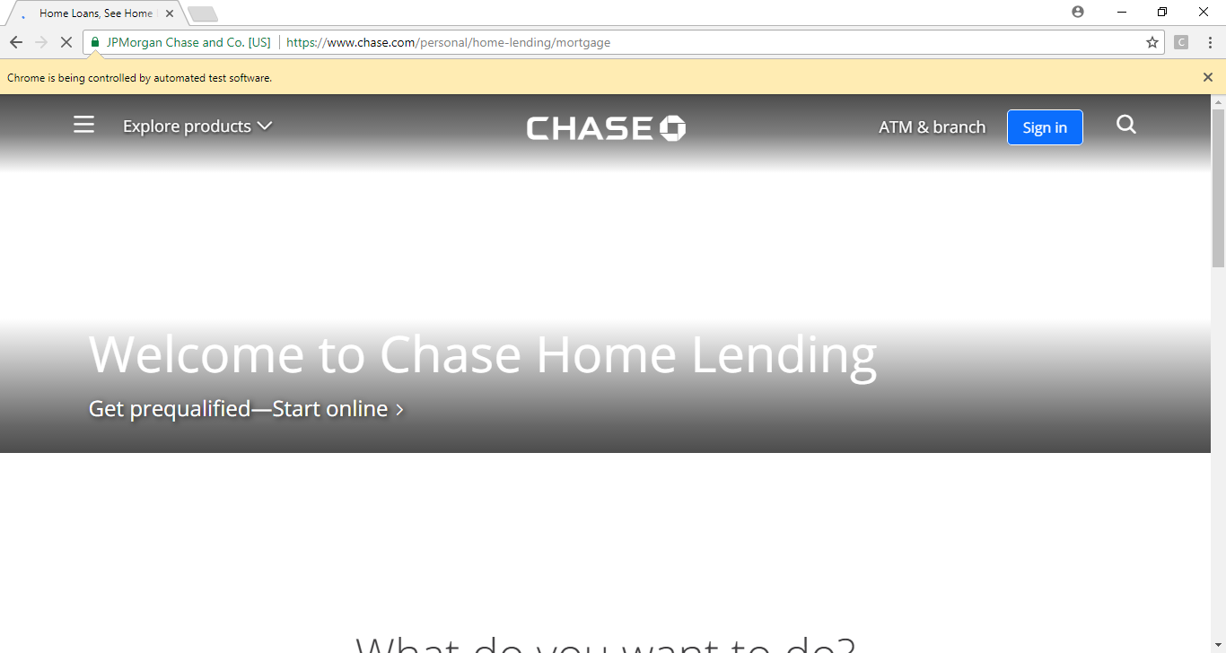

1. When each test case is running, it displays how many cases are passed and failed.

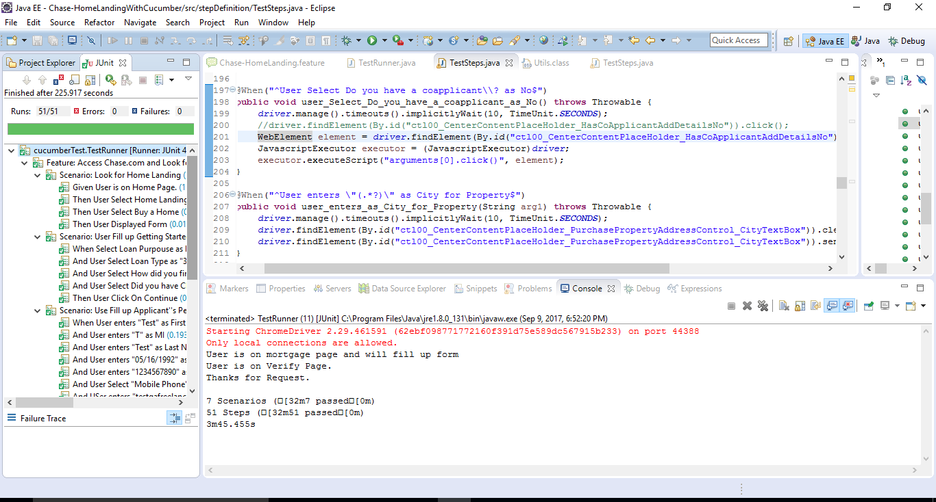

1. Congratulations, you were able to use cucumber to test Chase Mortgage Lending.
2. Walmart Shopping

|  |  |  |
| --- | --- | --- |
| Overview | |  |
| In this exercise, you will create tests for an active website. | | |
| Objective | Access Walmart.com and shop using Cucumber and Selenium Tests. | |

1. Create new Java project named **WalmartWithCucumber**
2. Add **Selenium** and **Cucumbe**r libraries to the project’s build path
3. Add the **Feature** folder to the project.
4. Add feature file to the **Feature** folder and name it “**Walmart.feature**”

Note: It is very important to use your own user name , password and your email address , your own address information, if asked for.

1. Write all the scenarios inside **Walmart.feature** file. Start by deleting all the existing feature file and write scenarios.

Now add the following:

Feature: Add & remove item in to the cart and go back to home page

Scenario: Search Iphone

Given User is on Home page

When User Select cellphone from Category

And User search for "Iphone"

Then Clicks On Search

Then User Displayed Successfully Searched result

Then User click on one litem from the given list

Then User select that product and click on add to cart

Then User navigate to basket page

Then User remove item from the basket

Then User navigate to home page

1. Create the “**cucumberTest**” package.
2. Create the “**TestRunner**” class in the “**cucumberTest**” package. Insert this code below into the class.

package cucumberTest;

@RunWith(Cucumber.class)

@CucumberOptions(

features = "Feature"

,glue={"stepDefinition"}

)

public class TestRunner {

}

public class TestRunner {

}

1. Create the new package “**stepDefinition**” and the new class “**TestSteps**” in the new package
2. Now right click on **TestRunner** class and click **Run As** > **JUnit Test**.
3. Copy all those steps and paste in **TestSteps.java** file and add code in those methods.
4. Add the bolded code to your **TestSteps** file.

package stepDefinition;

import java.util.ArrayList;

import java.util.List;

import org.openqa.selenium.By;

import org.openqa.selenium.WebDriver;

import org.openqa.selenium.WebElement;

import org.openqa.selenium.chrome.ChromeDriver;

import org.openqa.selenium.support.ui.Select;

import cucumber.api.PendingException;

import cucumber.api.java.en.Given;

import cucumber.api.java.en.Then;

import cucumber.api.java.en.When;

public class TestSteps {

**public static String DriverPath =**

**System.getProperty("user.dir") + "\\src\\Driver\\";**

**private static WebDriver driver = null;**

@Given("^User is on Home page$")

public void user_is_on_Home_page() throws Throwable {

**System.setProperty("webdriver.chrome.driver",**

**DriverPath + "chromedriver.exe");**

**driver = new ChromeDriver();**

**driver.get("https://www.walmart.com/");**

**driver.manage().window().maximize();**

}

@When("^User Select cellphone from Category$")

public void user_Select_cellphone_from_Category() throws Throwable {

**driver.findElement(By.id("listboxActive")).click();**

**driver.findElement(By.id("header-SearchDropdown-option-5")).click();**

}

@When("^User search for \"(.*?)\"$")

public void user_search_for(String arg1) throws Throwable {

**driver.findElement(By.id("global-search-input")).clear();**

**driver.findElement(By.id("global-search-input")).sendKeys("iphone");**

}

@Then("^Clicks On Search$")

public void clicks_On_Search() throws Throwable {

**driver.findElement(**

**By.cssSelector("button.header-GlobalSearch-submit.btn")).click();**

}

@Then("^User Displayed Successfully Searched result$")

public void user_Displayed_Successfully_Searched_result() throws Throwable {

**System.out.println("Searching Result Display..");**

}

@Then("^User click on one litem from the given list$")

public void user_click_on_one_litem_from_the_given_list() throws Throwable {

**driver.findElement(By.cssSelector("img.Tile-img")).click();**

}

@Then("^User select that product and click on add to cart$")

public void user_select_that_product_and_click_on_add_to_cart() throws Throwable {

**Thread.sleep(2000);**

**driver.findElement(By.xpath("(//button[@type='button'])[42]")).click();**

**Thread.sleep(2000);**

**driver.findElement(**

**By.cssSelector("button.modal_close-button")).click();**

}

@Then("^User navigate to basket page$")

public void user_navigate_to_basket_page() throws Throwable {

**driver.findElement(**

**By.cssSelector("span.elc-icon.elc-icon-cart")).click();**

**Thread.sleep(2000);**

}

@Then("^User remove item from the basket$")

public void user_remove_item_from_the_basket() throws Throwable {

**driver.findElement(By.xpath("(//button[@type='button'])[36]")).click();**

**Thread.sleep(2000);**

}

@Then("^User navigate to home page$")

public void user_navigate_to_home_page() throws Throwable {

**Thread.sleep(1000);**

**driver.findElement(By.id("header-Logo")).click();**

**driver.quit();**

}

}

1. Select **TestRunner.java** > right click > **Run As > JUnit Test**
2. It will open a browser and perform all cases.

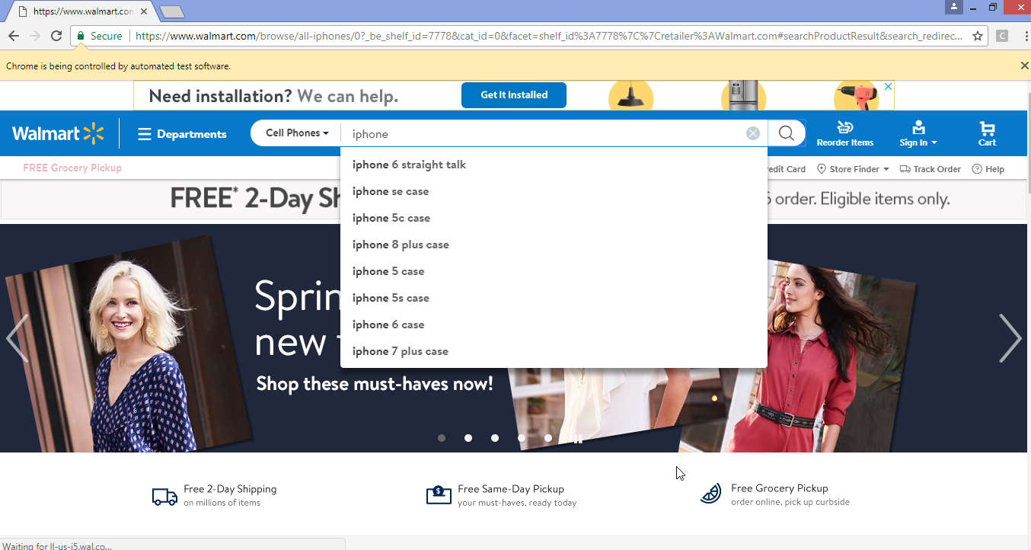

1. When each test case is running, it displays how many cases are passed and failed.

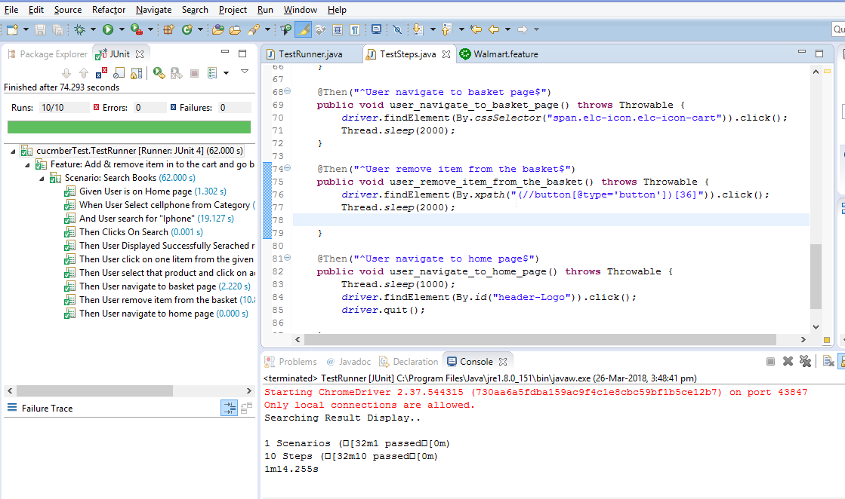

1. Facebook Login

|  |  |  |
| --- | --- | --- |
| Overview | |  |
| In this exercise, you will create tests for an active website. | | |
| Objective | Login into Facebook using Cucumber and Selenium Tests. | |

1. Create new Java project named **FacebookWithCucumberLogin**
2. Add **Selenium** and **Cucumbe**r libraries to the project’s build path
3. Add the **Feature** folder to the project.
4. Add feature file to the **Feature** folder and name it “**FaceBookLogin.feature**”

Note: It is very important to use your own user name and password for gmail, instead of “type you user name”, “type your password”

1. Write all the scenarios inside **FaceBookLogin.feature** file. Start by deleting all the existing feature file and write scenarios.

Now add the following:

Feature: Facebook Login Action

Scenario: Successful Login with Valid Credentials

Given User is on Home Page

And User enters Username "type you user name"

And User enters Password "type your password"

Then User Login

Then Message displayed Login Successfully

Scenario: Successful LogOut

When User LogOut from the Application

Then Message displayed LogOut Successfully

Scenario: Login without Credentials

When User enters Username ""

When User Login

Then Message displayed Invalid Login

1. Create the “**cucumberTest**” package.
2. Create the “**TestRunner**” class in the “**cucumberTest**” package. Insert this code below into the class.

package cucumberTest;

import org.junit.runner.RunWith;

import cucumber.api.CucumberOptions;

import cucumber.api.junit.Cucumber;

@RunWith(Cucumber.class)

@CucumberOptions(

features = "Feature"

,glue={"stepDefinition"}

)

public class TestRunner {

}

1. Create the new package “**stepDefinition**” and the new class “**TestSteps**” in the new package
2. Now right click on **TestRunner** class and click **Run As** > **JUnit Test**.
3. Copy all those steps and paste in **TestSteps.java** file and add code in those methods.
4. Add the bolded code to your **TestSteps** file.

package stepDefinition;

import java.util.concurrent.TimeUnit;

import org.openqa.selenium.Alert;

import org.openqa.selenium.By;

import org.openqa.selenium.NoAlertPresentException;

import org.openqa.selenium.WebDriver;

import org.openqa.selenium.chrome.ChromeDriver;

import org.openqa.selenium.chrome.ChromeOptions;

import org.openqa.selenium.firefox.FirefoxDriver;

import cucumber.api.java.en.Given;

import cucumber.api.java.en.Then;

import cucumber.api.java.en.When;

public class TestSteps {

**public static String DriverPath =**

**"C:\\StudentWork\\jars\\ChromeDriver\\";**

**public static WebDriver driver;**

@Given("^User is on Home Page$")

public void user_is_on_Home_Page() throws Throwable {

**ChromeOptions options = new ChromeOptions();**

**options.addArguments("--disable-notifications");**

**System.setProperty("webdriver.chrome.driver",**

**DriverPath + "chromedriver.exe");**

**driver = new ChromeDriver(options);**

**driver.manage().timeouts().implicitlyWait(10, TimeUnit.SECONDS);**

**driver.get("https://www.facebook.com");**

**driver.manage().window().maximize();**

}

@When("^User enters Username \"(.*?)\"$")

public void user_enters_Username(String arg1) throws Throwable {

**driver.findElement(By.id("email")).clear();**

**driver.findElement(By.id("email")).sendKeys(arg1);**

}

@When("^User enters Password \"(.*?)\"$")

public void user_enters_Password(String arg1) throws Throwable {

**driver.findElement(By.id("pass")).clear();**

**driver.findElement(By.id("pass")).sendKeys(arg1);**

}

@When("^User Login$")

public void user_Login() throws Throwable {

**driver.findElement(**

**By.xpath("//label[@id='loginbutton']/input")).click();**

}

@Then("^Message displayed Login Successfully$")

public void message_displayed_Login_Successfully() throws Throwable {

**System.out.println("Login Successfully");**

}

@When("^User LogOut from the Application$")

public void user_LogOut_from_the_Application() throws Throwable {

//driver.findElement(

// By.xpath(".//*[@id='account_logout']/a")).click();

**driver.findElement(By.id("userNavigationLabel")).click();**

**Thread.sleep(3000);**

//driver.findElement(

//By.xpath(

//"//div[@id='js_3k']/div/div/ul/li[12]/a/span/sp//an"))

// .click();

**driver.findElement(By.xpath("//li[12]/a/span/span")).click();**

}

@Then("^Message displayed LogOut Successfully$")

public void message_displayed_LogOut_Successfully() throws Throwable {

**System.out.println("LogOut Successfully");**

}

@When("^User Navigate to Login Page$")

public void user_Navigate_to_Login_Page() throws Throwable {

**driver.get("https://www.facebook.com");**

}

@Then("^Message displayed Invalid Login$")

public void message_displayed_Invalid_Login() throws Throwable {

**System.out.println("Please enter Username and Password.");**

**Thread.sleep(5000);**

}

@Then("^Message displayed Invalid Credentials$")

public void message_displayed_Invalid_Credentials() throws Throwable {

**System.out.println("Invalid Credentials.");**

}

}

1. Select **TestRunner.java** > right click > **Run As > JUnit Test**
2. It will open a browser and perform all cases.
3. While the test is running the test case it will then open the screen below.
4. It will then enter the username and password
5. Then, it will log into the page.

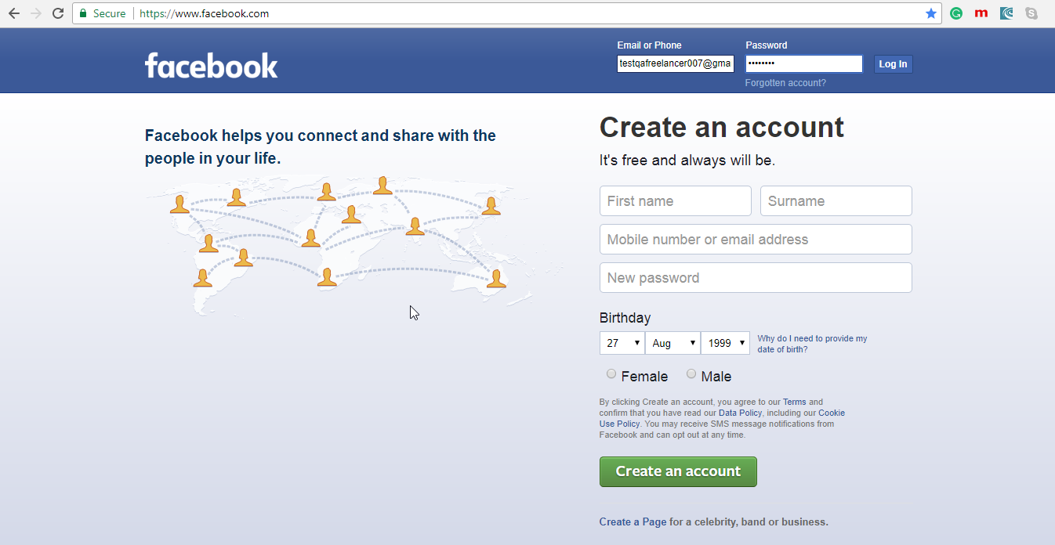

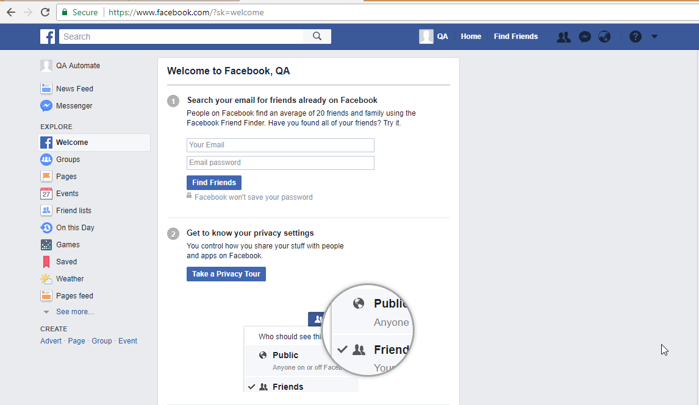

1. Congratulations, your Facebook test using Cucumber is done.
2. JetBlue Vacation

|  |  |  |
| --- | --- | --- |
| Overview | |  |
| In this exercise, you will create tests for an active website. | | |
| Objective | Access JetBlue to look for a vacation using Cucumber and Selenium Tests. | |

1. Create new Java project named **JetBlueWithCucumber**
2. Add **Selenium** and **Cucumbe**r libraries to the project’s build path

Note: It is very important to use your own user name , password and your email address , your own address information.

1. Add the **Feature** folder to the project.
2. Add feature file to the **Feature** folder and name it “**JetBlue.feature**”
3. Write all the scenarios inside **JetBlue.feature** file. Start by deleting all the existing feature file and write scenarios.

Now add the following:

**Feature: Plan Trip for Vacation**

**Scenario: Book for Vacation**

**Given User is on Home Page**

**When User click on See Vacation**

**Then User Click on Let’s Go Button**

**Then User Click on Search**

**Then User click on Choose this deal button**

**Then User click on Book**

**Then User click on Checkout**

1. Create the “**cucumberTest**” package.
2. Create the “**TestRunner**” class in the “**cucumberTest**” package. Insert this code below into the class.

**package cucumberTest;**

**@RunWith(Cucumber.class)**

**@CucumberOptions(**

**features = "Feature"**

**,glue={"stepDefinition"}**

**)**

**public class TestRunner {**

**}**

1. Create the new package “**stepDefinition**” and the new class “**TestSteps**” in the new package
2. Now right click on **TestRunner** class and click **Run As** > **JUnit Test**.
3. Copy all those steps and paste in **TestSteps.java** file and add code in those methods.
4. Add the bolded code to your **TestSteps** file.

package stepDefinition;

import org.openqa.selenium.By;

import org.openqa.selenium.JavascriptExecutor;

import org.openqa.selenium.WebDriver;

import org.openqa.selenium.WebElement;

import org.openqa.selenium.chrome.ChromeDriver;

import cucumber.api.PendingException;

import cucumber.api.java.en.Given;

import cucumber.api.java.en.Then;

import cucumber.api.java.en.When;

public class TestSteps {

**public static String DriverPath =**

**System.getProperty("user.dir") + "\\src\\Driver\\";**

**private static WebDriver driver = null;**

@Given("^User is on Home Page$")

public void user_is_on_Home_Page() throws Throwable {

**System.setProperty("webdriver.chrome.driver",**

**DriverPath + "chromedriver.exe");**

**driver = new ChromeDriver();**

**driver.manage().window().maximize();**

**driver.get("http://www.jetblue.com/plan-a-trip/#/");**

}

@When("^User click on See Vacation$")

public void user_click_on_See_Vacation() throws Throwable {

**JavascriptExecutor jse = (JavascriptExecutor) driver;**

**jse.executeScript("window.scrollBy(0,1300)", "");**

**Thread.sleep(3000);**

**// driver.findElement(By.linkText("See Vacations")).click();**

**driver.navigate().to("https://www.jetblue.com/vacations/deals/#/");**

}

@Then("^User Click on Lets Go Button$")

public void user_Click_on_Lets_Go_Button() throws Throwable {

**JavascriptExecutor ex = (JavascriptExecutor) driver;**

**ex.executeScript("arguments[0].click();",**

**driver.findElement(By.className("letsGoLink")));**

**Thread.sleep(6000);**

}

@Then("^User Click on Search$")

public void user_Click_on_Search() throws Throwable {

**driver.findElement(**

**By.cssSelector("button.submit_link.automation-submitLink")).click();**

**Thread.sleep(6000);**

}

@Then("^User click on Choose this deal button$")

public void user_click_on_Choose_this_deal_button() throws Throwable {

**driver.findElement(**

**By.xpath("(//button[@type='button'])[12]")).click();**

**Thread.sleep(6000);**

**driver.findElement(**

**By.xpath("(//button[@type='button'])[15]")).click();**

**Thread.sleep(6000);**

}

@Then("^User click on Book$")

public void user_click_on_Book() throws Throwable {

**driver.findElement(**

**By.xpath("(//button[@type='button'])[11]")).click();**

**Thread.sleep(6000);**

}

@Then("^User click on Checkout$")

public void user_click_on_Checkout() throws Throwable {

**driver.findElement(By.id("checkout-button")).click();**

}

}

1. Select **TestRunner.java** > right click > **Run As > JUnit Test**
2. It will open a browser and perform all cases.

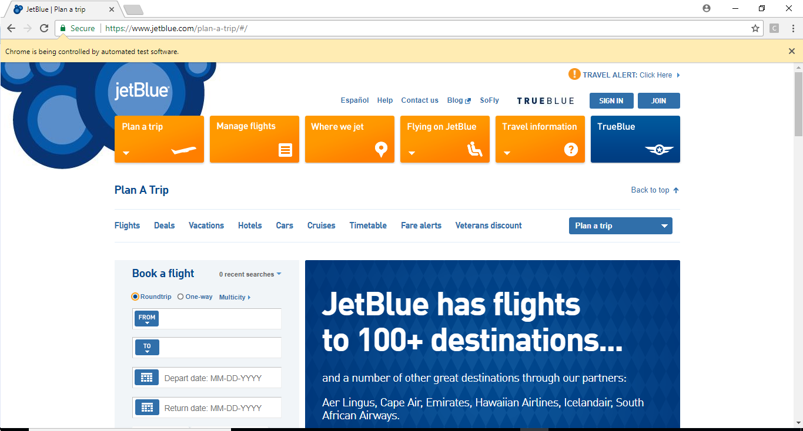

1. When each test case is running, it displays how many cases are passed and failed.

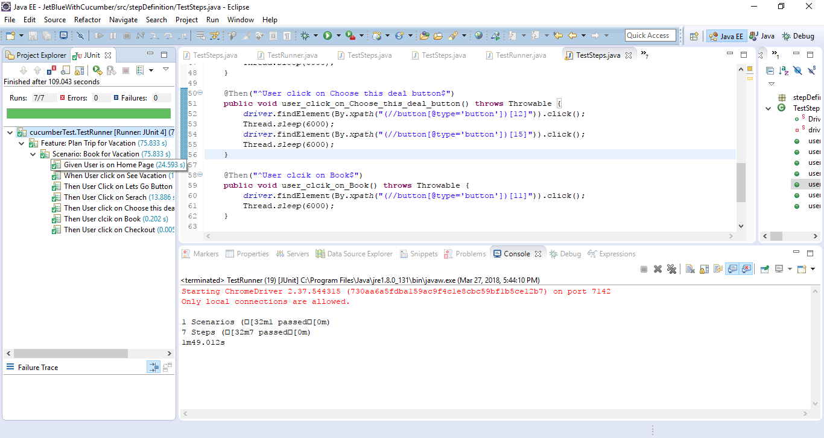

1. LinkedIn

|  |  |  |
| --- | --- | --- |
| Overview | |  |
| In this exercise, you will create tests for an active website. | | |
| Objective | Access LinkedIn using Cucumber and Selenium Tests. | |

1. Create new Java project named **LinkedinWithCucumber**
2. Add **Selenium** and **Cucumbe**r libraries to the project’s build path
3. Add the **Feature** folder to the project.
4. Add feature file to the **Feature** folder and name it “**LinkedinLogin.feature**”
5. Write all the scenarios inside **LinkedinLogin.feature** file. Start by deleting all the existing feature file and write scenarios.

Now add the following:

Feature: Access Gmail and Mail to Yourself.

Feature: Access LinkedIn and Send Update

Scenario: Login to LinkedIn

Given User is on Home Page

When User enters Username as "your user name"

And User enters Password as "your password"

Then User Click On Login

Then User Displayed Success Login

Scenario: Sending an Update

When User Click On Post Area

And Use enters Content as "Hello, This is Test Content." to Post

Then User Click on post

Then User Displayed Post Success

Scenario: : Logout Linked In

When User Click On Logout

Then User Displayed Logout Success

1. Create the “**cucumberTest**” package.
2. Create the “**TestRunner**” class in the “**cucumberTest**” package. Insert this code below into the class.

**package cucumberTest;**

**import org.junit.runner.RunWith;**

**import cucumber.api.CucumberOptions;**

**import cucumber.api.junit.Cucumber;**

**@RunWith(Cucumber.class)**

**@CucumberOptions(**

**features = "Feature"**

**,glue={"stepDefinition"}**

**)**

**public class TestRunner {**

**}**

1. Create the new package “**stepDefinition**” and the new class “**TestSteps**” in the new package
2. Now right click on **TestRunner** class and click **Run As** > **JUnit Test**.
3. Copy all those steps and paste in **TestSteps.java** file and add code in those methods.
4. Add the bolded code to your **TestSteps** file.

package stepDefinition;

import java.util.concurrent.TimeUnit;

import org.openqa.selenium.By;

import org.openqa.selenium.WebDriver;

import org.openqa.selenium.chrome.ChromeDriver;

import cucumber.api.java.en.Given;

import cucumber.api.java.en.Then;

import cucumber.api.java.en.When;

public class TestSteps {

**public static String DriverPath =**

**System.getProperty("user.dir") + "\\src\\Driver\\";**

**public static WebDriver driver;**

@Given("^User is on Home Page$")

public void user_is_on_Home_Page() throws Throwable {

**System.setProperty("webdriver.chrome.driver",**

**DriverPath + "chromedriver.exe");**

**driver = new ChromeDriver();**

**driver.manage().timeouts().implicitlyWait(10, TimeUnit.SECONDS);**

**driver.get("https://www.linkedin.com/");**

**driver.manage().window().maximize();**

}

@When("^User enters Username as \"(.*?)\"$")

public void user_enters_Username_as(String arg1) throws Throwable {

**driver.findElement(By.id("login-email")).clear();**

**driver.findElement(By.id("login-email")).sendKeys(arg1);**

}

@When("^User enters Password as \"(.*?)\"$")

public void user_enters_Password_as(String arg1) throws Throwable {

**driver.findElement(By.id("login-password")).clear();**

**driver.findElement(By.id("login-password")).sendKeys(arg1);**

}

@Then("^User Click On Login$")

public void user_Click_On_Login() throws Throwable {

**driver.findElement(By.id("login-submit")).click();**

}

@Then("^User Displayed Success Login$")

public void user_Displayed_Success_Login() throws Throwable {

**System.out.println("Successfully Login");**

}

@When("^User Click On Post Area$")

public void user_Click_On_Post_Area() throws Throwable {

**driver.findElement(**

**By.xpath("//div[2]/div/div[3]/div/div/div/div/div/button")).click();**

}

@When("^Use enters Content as \"(.*?)\" to Post$")

public void use_enters_Content_as_to_Post(String arg1) throws Throwable {

**driver.findElement(By.xpath("//textarea")).clear();**

**driver.findElement(By.xpath("//textarea")).sendKeys(arg1);**

}

@Then("^User Click on post$")

public void user_Click_on_post() throws Throwable {

**driver.findElement(By.xpath("//div/div[3]/div/div[2]/button")).click();**

}

@Then("^User Displayed Post Success$")

public void user_Displayed_Post_Success() throws Throwable {

**Thread.sleep(5000);**

**System.out.println("Successfully Post Done.");**

}

@When("^User Click On Logout$")

public void user_Click_On_Logout() throws Throwable {

**driver.findElement(By.id("nav-settings__dropdown-trigger")).click();**

**driver.findElement(By.linkText("Sign out")).click();**

}

@Then("^User Displayed Logout Success$")

public void user_Displayed_Logout_Success() throws Throwable {

**System.out.println("Successfully Logout.");**

}

}

1. Select **TestRunner.java** > right click > **Run As > JUnit Test**
2. It will open a browser and perform all cases.
3. When each test case is running, it displays how many cases are passed and failed.

